**\*\*\*KEY\*\*\***

**Second Body Systems Test Review**

**Nervous System – study your diagram**

Function 1: Receive information about what is happening inside and outside your body

Function 2: Directs how your body reacts to the information gathered

Function 3: Helps to maintain homeostasis

Your brain and spine make up what part of the nervous system?

Central Nervous System

The brain uses information received from where to coordinate actions?

Nerves

How are nerve impulses sent?

Electrical Impulses

What is a nerve cell called?

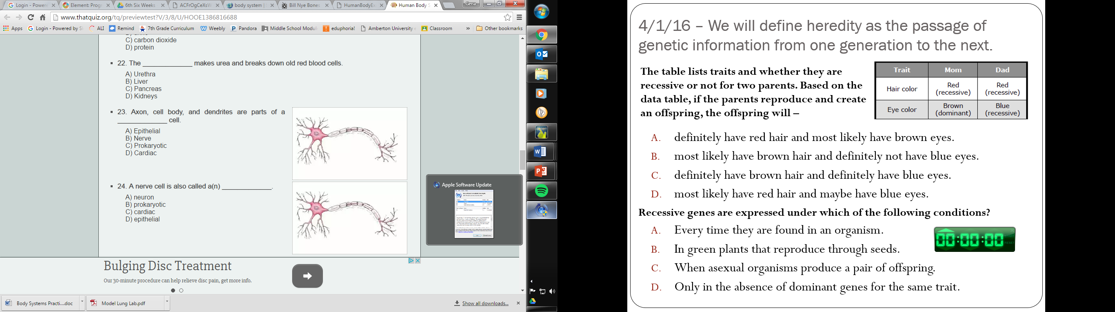Neuron

The brain uses information received from where to coordinate actions?

Nerves

**Digestive System – don’t forget to study your diagram and stemscope reading.**

Function 1:breaks down food into molecules the body can absorb.

Function 2:passes these molecules into the blood to be carried throughout the body.

Function 3:works to eliminate solid wastes from the body.

Food first passes through your __mouth__, then your __esophagus__, then your __stomach__, then your __small__ __intestine__, then your __large__ __intestine__, then your __rectum__, then finally out of your __anus__.

What are 3 organs that food doesn’t pass through, but aide in digestion and what is their function?

Liver – creates bile for the breakdown of fats

Gall Bladder – holds bile until the small intestine needs it

Pancreas – creates juices to help break down starches, proteins, and fats

**Excretory System - don’t forget to study your stemscope reading.**

Function 1: collects wastes produced by cells

Function 2: removes these wastes from your body

Urine is made in the __kidney__, then sent through the __ureter__ to the __bladder__, and excreted out of your body through your __urethra__.

Label the listed parts of the excretory system:

* Kidneys

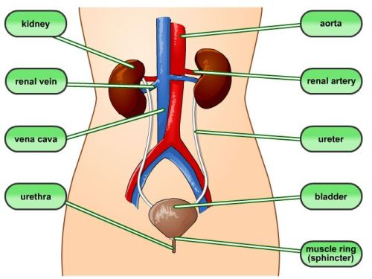

Kidney

Bladder

Urethra

Ureter

* Urethra
* Bladder
* Ureter

**Endocrine System – study your diagram**

Function: Produce hormones

What the organs of the endocrine system called?

Glands

What are the two types of main glands?

Pituitary (“master gland’ – controls other glands) and Adrenal (secretes adrenalin for fight or flight response)

What do hormones do for you?

Regulate body activities such as growth, sleep, sudden actions, feelings, and blood sugar

**Reproductive System – study your diagram**

Female Function 1: Produce eggs

Female Function 2: Nourish a developing baby until birth

What is the female hormone that is produced in the ovaries?

estrogen

What is the path an egg travels in a woman?

Ovary, fallopian tube, uterus

Eggs hold how many chromosomes?

23

Male Function 1: Produce sperm

Male Function 2: Produce testosterone

What is the male hormone that is produced in the testes?

Testosterone

What is the path of a sperm cell in a man?

Testicles, vas deferens, prostate gland

A single sperm cell hold how many chromosomes?

23

A fertilized egg is called what?

Zygote

How many months does it take for a fertile egg to develop and grow into a baby?

9 months