Name____________________________________________________Date_________Period______

Newton's Laws and Energy Transformations Test Review

- What is Newton's First Law of Motion?
An object at rest stays at rest or an object in motion stays in motion until unbalanced forces act upon it.

- Define inertia.
Objects will continue sitting still or moving in the same direction and speed unless a force changes it.

- Give an example of an object having inertia while stopped.
A book sitting on a table.

- Give an example of an object having inertia while moving.
A person running.

- How's is Newton's First Law applied to objects in a moving car?
When the car stops, the objects will continue to move forward.

If the car speeds up, the objects will move backwards in the car.

When the car turns, the objects will lean the opposite way to try to keep moving in the original direction.

- What is Newton's Second Law of Motion?
Force = mass x acceleration

- Draw the triangle used with the force formula.
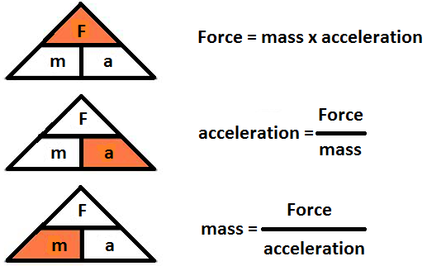

- What is the force used to accelerate a 50kg object at 4 m/s/s?
F=ma
F=(50kg)(4m/s²)
F=200N

- How much mass does an object have that decelerated 6 m/s² after hit with 60N of force?
m=F/a
m=60N/6m/s²
m=10kg
- A 30kg object is pushed with 2.5N of force. What is the acceleration?
a=F/m
a=2.5N/30kg
a=0.1m/s²
(Sorry, it was supposed to be 30N and 2.5kg for an answer of 12m/s²)

- What is the relationship between mass and acceleration?
As mass goes up, acceleration goes down.

- What is the relationship of force and acceleration?
As force goes up, acceleration goes up.

- What is Newton's Third Law of Motion?
For every action, there is an equal and opposite reaction.

- Give an example of Newton's Third Law.
A person on skateboard throws a basketball and moves backwards. The force the person puts on the ball is equaled by the force the ball puts on the person. So, it pushes the person backwards.

- How does your hand hurting when you hit something explained by Newton's Third Law?
The force you exert on the wall with your hand, is also the amount of force the wall exerts onto your hand.

- Complete the following acronym and write an example for each energy:
Alternative – solar (panels), wind (mills/turbines), water (dams), geothermal (u-shaped pipes underground)

Radiant – light (sun, light bulb, glow stick)
Electrical – electricity (power lines, iPads, phones, hair dryer)
Chemical – fossil fuels (coal, oil, natural gas), food, batteries
Thermal – heat (stove, fire, sun)
nUclear – fusion (sun), fission (power plant with uranium)
Mechanical – moving objects (objects falling, moving car, moving person)

Potential – stored (has the possibility to move)
Kinetic – moving

- What energy transformation happens in your iPad?
Chemical (battery) to electrical to radiant

- What energy transformation happens in you?
Chemical (food) to electrical (nerves)/thermal (body heat)/mechanical (movement)

- What energy transformations take place for there to be electricity in the school from a coal burning power plant?
Chemical (coal) to thermal (burning coal) to mechanical (spin generator) to electrical

- What energy transformations take place for there to be electricity in the school from a wind mill?
Mechanical (wind) to mechanical (turning generator) to electrical

