7.5C Flow of Energy Test Review KEY
- HOW WE KNOW our energy flow model is representative of energy flow in nature:

Food chains use only a small sampling of organisms

2. To show how many organisms are at each level of a food chain, ecologists use a model called

A energy pyramid

3. Only a small amount of the energy stored in food is available to the next organism in a food chain because…

most of the energy is used for life processes

4. One model that shows how energy passes from organism to organism is called?

A food chain

5. What do ecologists call the transfer of energy that begins with the Sun and passes from one organism to the next in a food chain?

A food web

6. ______ are autotrophic organisms with the ability to carry on photosynthesis and to make food for themselves.

Producers

7. Examples of consumers include ____________.

Primary, Secondary, and Tertiary Consumers

8. Energy flows through an ecosystem because when one form of energy is transformed into another form, and there is always a loss of some energy as heat.
True
9. With every energy transformation, some energy is degraded into a less available form such as ___________ .

Calories

10. How is energy measured?

Calories

11. Joni swims in Barton Springs, a natural spring-fed watering hole in Austin. Which food chain shows the energy flow through the living things at Barton Springs?

Sun → algae → water insects → small fish → large fish

12. A ___________ indicates who eats whom in an ecosystem.

A food web

13. When numerous food chains link to each other in an ecosystem, it is known as a(n) ____________.
Food Web

14. What is another term for a third level consumer?

Tertiary consumer

15. It is generally stated that only about ______ % of the energy available at one trophic level is incorporated into the tissues of animals at the next level.

10

16
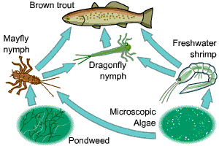
In this food web, what is represented by the arrows?

Energy transfer

17. Which of these organisms is a producer?

Pondweed

18. As energy is transferred along the food chain some of it is 'lost'. What happens to the 'lost' energy?

It goes into growth, It is used to produce offspring, It returns to the environment

19.
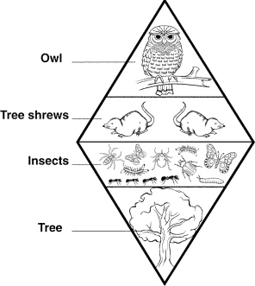
The trophic levels in the image above represent …
the relative number of individual organisms at each level.
20. What is the original source of almost all the energy in most ecosystems?

Sunlight

