8.11C Environmental Changes
- An illustration of a water lily is provided. If annual rainfall increased and caused ponds in this habitat to become deeper, how, after many generations, might the traits of these water lilies change?
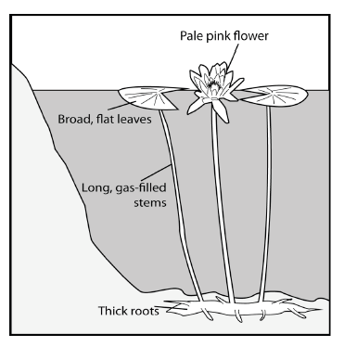
A Brighter flowers
B Longer stems
C Wider leaves
D Thicker roots
- Koalas live almost entirely on leaves from eucalyptus trees and they are native exclusively to Australia. Destruction of the Koalas’ habitat will most likely lead to -
A koalas eating other kinds of leaves.
B the koalas becoming larger.
C the reduction of the koala population.
D koalas producing more offspring.
- The Resurrection Fern (Selaginella lepidophylla) can shrivel up into a ball and remain that way for many years. When moisture is available, the dry leaves absorb the water and unroll. The plant will then turn green and grow. Under which environmental conditions did this ability develop?
A Atmosphere with little carbon dioxide
B Climate including periods of prolonged drought
C High density of many competitor plant species
D Abundant insect pollinators of many varieties
- Human activity can affect the organisms and populations in an environment. Look at the diagram provided.
What percentage of organisms and populations may be able to adapt to the long-term changes caused by human activity? Record and bubble in your answer into the answer grid provided.
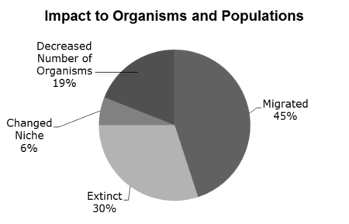
- The population of an organism will likely decrease if there is an increase in -
A soil nutrients available to the organism.
B predators that prey on the organism.
C food resources eaten by the organism.
D rainfall in the habitat of the organism.
- The Grey Mangrove tree (Avicennia marina) grows in the salty, coastal regions of South America, Africa, and Australia. Mangrove forests are found in areas where high tide brings in salt water and then the tide recedes, leaving the soil behind very salty. Which of the following traits would be found in populations of Mangroves living in this environment?
A Underground bulbs for the storage of food
B Flowers which attract insect pollinators
C Roots which can filter out salt
D Leaves which can reduce water absorption
- Bank swallows are birds that make their nests on the edges of rivers but can’t swim or breathe underwater. They feed on flying insects and in the spring, they lay four or five eggs. What change in these birds will likely be brought about by flooding in their habitat?
A Laying more eggs in the spring
B Building nests higher up the banks
C Eating different kinds of insects
D Learning to breathe underwater
- Each year, an area of the Gulf of Mexico becomes very low in oxygen due to increased growth of algae caused by excessive runoff from the Mississippi River. Which of the following statements reflects the most likely effects of decreased oxygen on aquatic organisms? Aquatic organisms -
A begin using algae as a food source.
B move to an area with more oxygen.
C start to breathe carbon dioxide gas.
D compete with the algae for space.
- The peppered moth (Biston betularia) has two forms, a white-bodied and a dark-bodied form. The table provided shows the percentages of each type in a moth population over several years time. What environmental change would lead to these changes in the population of peppered moths?
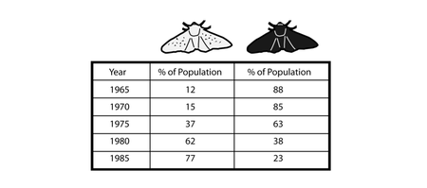
A The primary food sources for the peppered moths disappears.
B The trees where peppered moths rest become lighter in color.
C Predators of peppered moths develop a distaste for dark colored moths.
D The climate in the area where the moths live suddenly becomes much cooler.
- Robins migrate south during the winter months to avoid harsh conditions and then return north during the summer. What environmental condition are the robins most likely responding to in order to determine when the seasons are changing?
A The tilt of Earth on its axis
B Fluctuations in predator populations
C Changing length of daylight hours
D Increasing availability of water
- Some species of frogs live in freshwater ponds, eat bugs, and are prey to heron. These frogs survive loss of water by estivation (an inactive state of deep sleep during the summer). During a period of prolonged drought, which of the following changes to the population of frogs would be expected? The drought would lead to frogs that -
A eat more bugs.
B require less sunlight.
C estivate longer.
D can hide from heron.
- Snowshoe hares are related to rabbits and live in cold regions. In warm weather, they have a brown coat and spend many hours feeding on vegetation. To avoid predators they either remain still and try to blend into their habitat, or use their powerful hind legs to flee. What change brought about by the winter season would help these animals avoid predators in the snowy climate?
A Their bodies slow down and require less food.
B They spend more of the day sleeping.
C Their brown fur changes to white.
D They must search longer to find vegetation.
- A diagram of the anatomy of a catfish is provided. Catfish have dorsal fin spines, which help defend against predators and caudal fins, which help to propel the fish through the water. A swim bladder controls how high or low the fish sits in the water and gills allow the fish to breathe by taking oxygen out of the water. Catfish spend most of their lives at the bottom of freshwater lakes and streams. What catfish trait may change (over many generations) if the pond habitat in which it lives becomes significantly deeper?
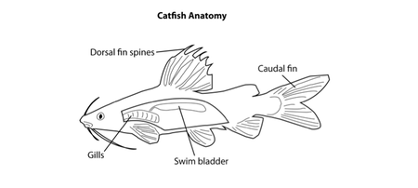
A Dorsal fin
B Caudal fin
C Swim bladder
D Gills
- The Dead Sea has a salt concentration of 33%, which makes it inhospitable for aquatic plants and animals. During rainy seasons, the concentration of salt decreases and some kinds of algae begin to grow. What changes could be expected when the salt concentration returns to normal?
A Increased algae growth
B Plant life flourishes
C Algae dies off
D Animals return to the area
- The Venus Fly Trap (Dionaea muscipula) is a plant, and like all other green plants, gets its energy from the Sun through photosynthesis. This plant, however, catches flies and breaks down their bodies using the chemicals to meet its needs. Which environmental condition has led to this adaptation?
A Excessive insect populations
B Soil with few nutrients
C Low atmospheric oxygen
D Increased average daily temperatures
- Three-toed tree sloths are mammals which live in the jungle trees of Central and South America. The majority of a sloth’s diet consists of leaves and buds from trees. As rainforest habitats are being destroyed, how will these organisms most likely be affected?
A Most sloths will become carnivores.
B The sloth population will likely decrease.
C Some sloths will start to hibernate.
D A cave-dwelling population will appear.
- Some individuals of the species, Crocodylus niloticus, the Nile Crocodile, have been found living in caves deep underground. The cave dwelling population of crocodiles is thriving, while their counterparts living outside the caves have been almost completely eliminated. Which of the following changes most likely led to these crocodiles relocating to a new habitat?
A Temperatures have steadily increased over time.
B The food sources of these animals are more scarce.
C Expansion of the habitat has led to less competition.
D Annual rainfall levels have changed greatly.
- The types of small organisms that live on the bottom of streams can be good indicators of water pollution. The table below groups some organisms by their tolerance of pollution.
A certain stream that was historically clear and clean has become increasingly polluted with fertilizer waste over the years. Which of these describes a likely result of this pollution?
A Mayflies that were previously abundant are no longer present in the stream.
B Stone flies and midges thrive and compete for the same food source.
C Large numbers of crayfish have suddenly died.
D Riffle beetles have become more abundant in the stream.
- Galveston Bay, an estuary in Southeast Texas, is shown below. The amount of salt in the water changes with the tides. Sometimes the water is mostly freshwater, and sometimes it is mixed with saltwater. Various plant species live in this environment and provide a habitat for other organisms.
To successfully live in an estuary, a plant species must have an adaptation that allows it to —
A produce large amounts of food
B absorb large amounts of water
C store excess gases
D filter excess salt
- Some scientists studying aquatic plants notice that flooding often leads to a decrease in the rate of photosynthesis among aquatic plants. Flooding causes more sediment to be suspended in the water. The increased sediment concentration decreases the amount of light that reaches the plants. Why does a decreased rate of photosynthesis lead to a decrease in the plant population?
A Less water is available for absorption.
B Less tissue is available for plant growth.
C Less energy is available for reproduction.
D Less soil is available for leaf development.

