On your review, you need to justify why you think the answer to each question is correct.

- A diagram of a food web for an African grassland is shown. The greatest competition would most likely occur, if which of the following organisms were to decrease?
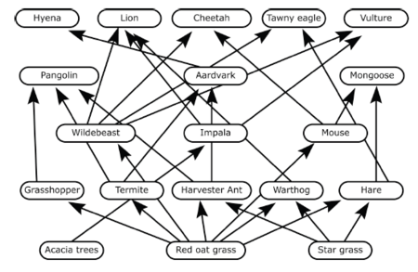

- For which resources do trees in a temperate deciduous forest compete?

- Prairie dogs are small mammals. They are primarily herbivores that live in underground burrows in grassland prairie ecosystems. Prairie dogs depend on burrows for –

- Brown-tailed bats are small flying mammals. They travel great distances at night hunting for insects and spend their days living in limestone caves. Some populations of these bats have been found living under man-made bridges. If humans tear down a bridge that supports a colony of bats, the bats must find another –

- Examine the diagram provided. Based on the diagram, which two organisms compete for food resources?
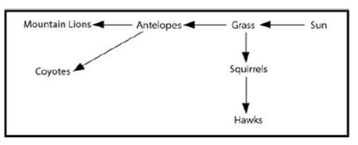

- Male Bowerbirds are black, medium-sized birds that live in New Guinean rainforests. Once a year they create elaborate nest-like structures to attract a female. Male Bowerbirds use sticks and leaves to build their structures and decorate them using brightly colored objects, including beetles. To attract a mate, male Bowerbirds depend on –

- Cattails grow near the edges of lakes, ponds and rivers. Like all other green plants, they turn sunlight into sugar that they use for food. Ducks eat the cattails to get the energy stored in them. The relationship between cattails and ducks is best classified as:

- Describe a terrestrial parasite/host relationship.

- The marine food web is provided.
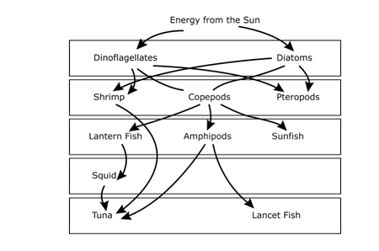
Use this food web to describe a predator/prey, and a producer/consumer relationship.

YOU NEED TO ALSO MAKE SURE THAT YOU STUDY YOUR VOCABULARY FOR THE TEST!!

