2014 8th Grade Science Semester Exam REVIEW
Atomic Structure and Chemistry
- How do you determine the mass of an atom?
- How do you determine the atomic number of an atom?
- Describe the location, mass and charge for:
Proton:
Neutron:
Electron:
- Which particles in an atom determine the chemical reactivity of the element?
- Locate Metals, Non-Metals, Metalloids on the Periodic Table of the Elements.
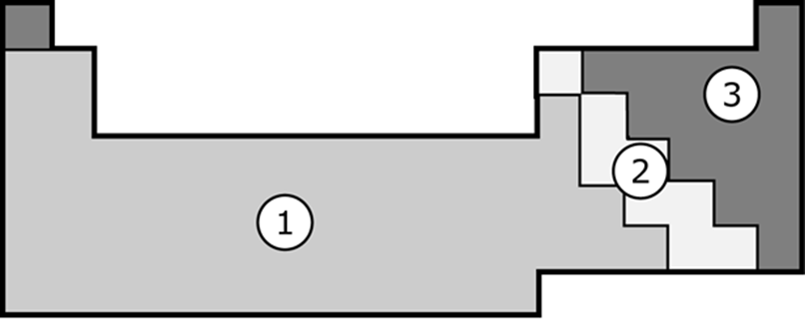
- Which direction do you move in the periodic table for increasing mass?
- How do you know if an element reacts like another element?
- What is the difference between an element and a compound?
- List evidence that a chemical reaction has occurred
a.
b.
c.
d.
e.
- What information can you get from a chemical formula? (Hint: Tell everything you can about this formula: C₂O₂H₄)
- Determine if the following equation is balanced (follows the Law of Conservation of Mass) using a RAP chart.
light
C₃H₈ + 5 O₂ 3 CO₂ + 4 H₂O
Physics
- How do you compute the density of an object?
- What is the difference between Speed, Velocity and Acceleration? (Hint: list definitions to help you!)
- What is inertia?
- Illustrate and describe an example of when an object will move according to the forces acting on it. (Hint: Balanced and unbalanced forces, direction of movement.)
- Given the force and acceleration of an object, how do you compute the object’s mass?
- What is the equation for determining force?
- What is the force on an object with a mass of 0.23kg, and an acceleration of 3.5m/s²?
- If two objects with different masses travel down a hill at the same speed, which object will require more force to stop?
Components of the Universe
- Why can people on Earth NOT see the shape of the Milky Way?
- What information is available on a Hertzsprung-Russell diagram?
- What is a light year?
- What is the distance from the earth to the sun? What is the distance from the earth to the next closest star?
- Write the following types of electromagnetic radiation in order from longest wavelengths to shortest.
X-rays Microwaves Gamma Rays Infrared Ultraviolet Visible Light Radio Waves
- Write the following colors of the visible light spectrum in order from longest wavelengths to shortest.
Indigo Red Green Orange Blue Yellow Violet (Purple)
- Astronomers use the visible spectrum to complete a spectral analysis of stars. What does the spectral analysis tell them?
- Draw a diagram of the phases of the moon, including: New Moon, Full Moon, 1st Quarter Moon, 3rd Quarter Moon, Sun and Earth. Label the order of the appearance of each phase.

