Biomes

Desert
We've all seen deserts in the movies. They are full of miles and miles of sand dunes. However, not all deserts are like this. Many deserts are rocky with scattered plants and shrubs. There are even deserts that are icy and cold. On this page we will describe the hot and dry deserts. You can read about the icy cold polar deserts that are found in the Antarctic and the North Pole.
What makes a desert a desert?
Deserts are primarily defined by their lack of rain. They generally get 10 inches or less rain in a year. Deserts are characterized in an overall lack of water. They have dry soil, little to no surface water, and high evaporation. They are so dry that sometimes rain evaporates before it can hit the ground!
Hot in the Day, Cold at Night
Because deserts are so dry and their humidity is so low, they have no "blanket" to help insulate the ground. As a result, they may get very hot during the day with the sun beating down, but don't hold the heat overnight. Many deserts can quickly get cold once the sun sets. Some deserts can reachtemperatures of well over 100 degrees F during the day and then drop below freezing (32 degrees F) during the night.
Where are the major hot and dry deserts?
The largest hot and dry desert in the world is the Sahara Desert in Northern Africa. The Sahara is a sandy desert with giant sand dunes. It covers over 3 million square miles of Africa. Other major deserts include the Arabian Desert in the Middle East, the Gobi Desert in Northern China and Mongolia, and the Kalahari Desert in Africa. Go here to learn more about the World's deserts.
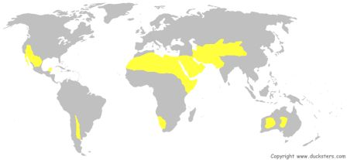
How do animals survive in the desert?
Animals have adapted to survive in the desert despite its extreme temperatures and lack of water. Many of the animals are nocturnal. Meaning they sleep during the heat of the day and come out when it is cooler at night. These same animals sleep in burrows, tunnels under the ground, during the day in order to stay cool. Desert animals include meerkats, camels, reptiles such as the horned toad, scorpions, and grasshoppers.
Animals that live in the desert also have adapted to needing little water. Many get all the water they need from the food they eat. Other animals store up water that they can use later. The camel stores up fat in its hump while other animals store up reserves in their tails.
What plants can live here?
Only certain types of plants can survive the harsh environment of the desert. These include cactus, grasses, shrubs, and some short trees. You won't see a lot of tall trees in the desert. Most of these plants have a way to store water in their stems, leaves, or trunks so they can survive a long time without water. They also tend to be spread out from each other and have a large root system so they can gather up all the water possible when it does rain. Many desert plants are armed with sharp spines and needles to help protect them from animals.
Dust Storms
Because the desert is so dry, the wind will grind pebbles and sand into dust. Occasionally a big wind storm will gather up this dust into a huge storm. Dust storms can be over 1 mile high and so thick with dust you can't breathe. They can travel for over a thousand miles, too.
Expanding Deserts
Currently deserts cover around 20% of the world's land, but they are growing. This is called desertification and is caused by different factors including human activities. The Sahara Desert is expanding at the rate of around 30 miles per year.
Facts about the Desert Biome
- The giant saguaro cactus can grow 50 feet tall and live for 200 years.
- Plants that store water in their stems are called succulents.
- Some desert trees have deep taproots that grow up to 30 feet deep in order to find water.
- The elf owl will sometimes live inside a cactus during the day and then come out at night to hunt.
- Dust storms from the Gobi Desert have been known to reach Beijing, China nearly 1,000 miles away.
- Camels can go without water for a week. A thirsty camel can drink 30 gallons of water in less than 15 minutes.

Biomes

Grasslands
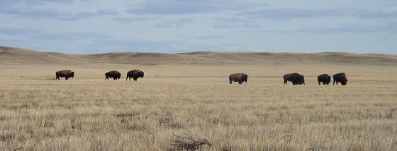
The grasslands biome can be divided up into the temperate grasslands and tropical grasslands. On this page we will discuss the temperate grasslands. Tropical grasslands are also called savannas. You can read more about this biome on the savanna biome page.
What are grasslands?
Grasslands are wide expanses of land filled with low growing plants such as grasses and wildflowers. The amount of rain is not enough to grow tall trees and produce a forest, but it is enough to not form a desert. The temperate grasslands have seasons including a hot summer and a cold winter.
Where are the major world grasslands?
Grasslands are generally located between deserts and forests. The major temperate grasslands are located in central North America in the United States, in Southeast South America in Uruguay andArgentina, and in Asia along the southern portion of Russia and Mongolia.
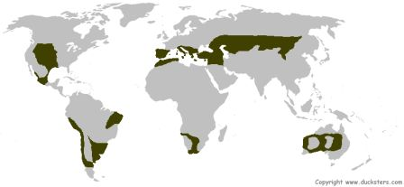
Types of Temperate Grasslands
Each major area of grasslands in the world has its own characteristics and is often called by other names:
- Prairie - Grasslands in North America are called the prairies. They cover around 1.4 million square miles of the central United States including some of Canada and Mexico.
- Steppes - The steppes are grasslands that cover southern Russia all the way to the Ukraine and Mongolia. The steppes stretch over 4,000 miles of Asia including much of the fabled Silk Road from China to Europe.
- Pampas - The grasslands in South America are often called the pampas. They cover around 300,000 square miles between the Andes Mountains and the Atlantic Ocean.
Animals in the Grasslands
A variety of animals live in the grasslands. These include prairie dogs, wolves, turkeys, eagles, weasels, bobcats, foxes, and geese. A lot of smaller animals hide down in the grasses such as snakes, mice, and rabbits.
The North American plains were once full of bison. These large herbivores ruled the plains. It is estimated there were millions of them before the Europeans arrived and began slaughtering them in the 1800s. Although there are numerous bison in commercial herds today, there are few in the wild.
Plants in the Grasslands
Different kinds of grass grow in different areas of the grasslands. There are actually thousands of different kinds of grasses that grow in this biome. Where they grow usually depends on the amount of rain that area gets. In wetter grasslands, there are tall grasses that can grow up to six feet high. In dryer areas the grasses grow shorter, maybe only a foot or two tall.
Types of grasses that grow here include buffalo grass, blue grama grass, needle grass, big bluestem, and switchgrass.
Other plants that grow here include sunflowers, sagebrush, clover, asters, goldenrods, butterfly weed, and butterweed.
Fires
Wildfires can play an important role in the biodiversity of the grasslands. Scientists believe that occasional fires help to rid the land of old grasses and allow for new grasses to grow, bringing new life to the area.
Farming and Food
The grassland biome plays an important role in human farming and food. They are used to grow staple crops such as wheat and corn. They are also good for grazing livestock such as cattle.
The Shrinking Grasslands
Unfortunately, human farming and development has caused the grassland biome to steadily shrink. There are conservation efforts going on to try and save the grasslands that are left as well as the endangered plants and animals.
Facts about the Grassland Biome
- Forbs are plants that grow in the grasslands that aren't grasses. They are leafy and soft-stemmed plants such as sunflowers.
- Prairie dogs are rodents that live in burrows under the prairies. They live in large groups called towns that can sometimes cover hundreds of acres of land.
- It is thought that there were over a billion prairie dogs on the Great Plains at one point.
- Other grassland animals need the prairie dog to survive, but the population is declining.
- Only around 2% of the original prairies of North America still exist. Much of it has been turned into farmland.
- Fires on grasslands can move as fast as 600 feet per minute.

Biomes

Savanna Grasslands
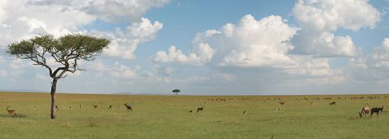
The savanna is a type of grasslands biome. The savanna is sometimes called the tropical grasslands. To learn about the other major type of grasslands biome, go to our temperate grasslands page.
Characteristics of the Savanna
- Grasses and trees - The savanna is a rolling grassland with scattered trees and shrubs.
- Rainy and dry seasons - Savannas have two distinct seasons in regards to precipitation. There is a rainy season in the summer with around 15 to 25 inches of rain and a dry season in the winter when only a couple of inches of rain may fall.
- Large herds of animals - There are often large herds of grazing animals on the savanna that thrive on the abundance of grass and trees.
- Warm - The savanna stays pretty warm all year. It cools down some during the dry season, but stays warm and humid during the rainy season.
Where are the major savanna biomes?
Savannas are generally found between the desert biome and the rainforest biome. They are mostly located near the equator.
The largest savanna is located in Africa. Nearly half of the continent of Africa is covered with savanna grasslands. Other major savannas are located in South America, India, and northern Australia.
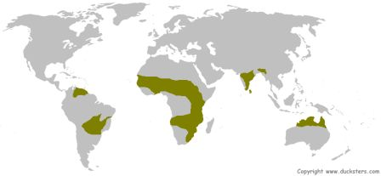
Animals in the Savanna
One of the more spectacular sights in nature is the animals of the African Savanna. Because the savanna is so rich in grasses and tree life, many large herbivores (plant eaters) live here and congregate in large herds. These include zebras, wildebeests, elephants, giraffes, ostriches, gazelles, and buffalo. Of course, where you have lots of herbivores, there must be predators. There are many powerful predators roaming the savanna including lions, hyenas, cheetahs, leopards, black mambas, and wild dogs.
The plant eating animals have developed ways at avoiding predators. Some animals like the gazelle and ostrich use speed to try and outrun predators. The giraffe uses its height to spot predators from far off and the elephant uses its shear size and strength to keep predators away.
At the same time predators of the savanna have adapted their own special skills. The cheetah is the fastest land animal and can run in bursts of 70 miles per hour to catch its prey. Other animals, like lions and hyenas, hunt in groups and trap the weaker animals away from the protection of the herd.
One reason that so many different kinds of plant eating animals can live on the savanna is that different species have adapted to eat different plants. This may be a different type of plant or even plants at different heights. Some animals are built to eat low grass while others, like giraffes, are designed to eat leaves high up in trees.
Plants in the Savanna
The majority of the savanna is covered in different types of grasses including lemon grass, Rhodes grass, star grass, and Bermuda grass. There are also lots of trees scattered about the savanna. Some of these trees include the acacia tree, the baobab tree, and the jackalberry tree.
The plants need to be able to survive the dry season and drought in the savanna. Some store water and energy in their roots, bulbs, or trunks. Others have roots that go deep into the ground to reach the low water table.
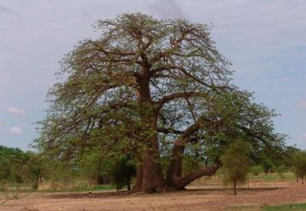
The baobab tree
Fires in the Savanna
Fires are an important part of the savanna. During the dry season fires clear out old dead grass and make way for new growth. Most of the plants will survive because they have extensive root systems that allow them to grow back quickly after a fire. The trees have thick bark which helps them to survive. The animals generally can run to escape the fire. Some animals burrow deep into the ground to survive. Insects generally die by the millions in a fire, but this provides a feast to many birds and animals.
Is the savanna in danger?
Overgrazing and farming has destroyed much of the savanna. When overgrazing occurs, the grasses don't grow back and the savanna can turn into desert. In Africa, the Sahara desert is expanding into the savanna at the rate of 30 miles per year.
Facts About the Savanna
- Many animals of the savanna are endangered due to overhunting and loss of habitat.
- The grassland in Australia is called the Bush.
- Many animals migrate out of the savanna during the dry season.
- Some animals in the savanna, like vultures and hyenas, are scavengers which eat other animal's kills.
- The African savanna boasts the largest land animal, the elephant, and the tallest land animal, the giraffe.
- The baobab tree can live for thousands of years.
- The savanna has the highest biodiversity of herbivore animals of any biome.
- Many of the animals in the savanna have long legs which helps them when migrating long distances.

Biomes  Tundra | 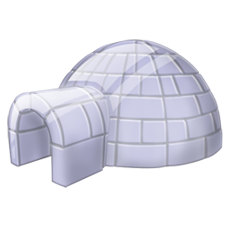
The tundra biome is a cold and treeless plain where harsh conditions make it hard for plants and animals alike to survive. Around 20% of the Earth's land surface is covered with tundra.
Characteristics of the Tundra Biome
- It's cold - The tundra is the coldest of the biomes. The average temperature in the tundra is around -18 degrees F. It gets much colder in the winter and warmer during its short summer.
- It's dry - The tundra gets about as much precipitation as the average desert, around 10 inches per year. Most of this is snow.
- Permafrost - Below the top soil, the ground is permanently frozen year round.
- It's barren - The tundra has few nutrients to support plant and animal life. It has a short growing season and a slow rate of decay.
Two Types of Tundra
- Alpine tundra - Alpine tundra is the area of land high in the mountains above the tree line.
- Arctic tundra - The Arctic tundra is located far north in the northern hemisphere along the Arctic Circle. There are large areas of tundra in northern North America, northern Europe, and northern Asia.
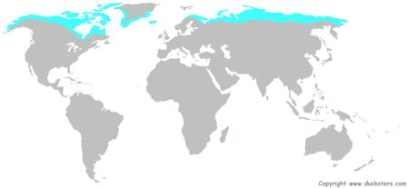
Tundra Seasons
The tundra has two distinct seasons: a long winter and a short summer. Being so far north, the tundra has long nights in the winter and long days in the summer.
The winter lasts around 8 months and is extremely cold. In the middle of winter the sun may not rise for weeks. The tundra is frozen and often covered with snow during the winter and will reach temperatures of -60 degrees F.
The summer is shorter and is marked by the other extreme of the sun not setting. In the middle of summer the sun will be up for 24 hours. During the summer the temperatures may reach 50 degrees F causing the snow to melt in areas and wetlands to form.
What is permafrost?
Permafrost is a layer of ground below the topsoil that remains frozen throughout the year. This layer is generally only a few feet below the surface. Permafrost prevents trees from growing in the tundra because trees need to have deep roots and they can't grow in the frozen ground.
Plants in the Tundra
Plants that grow in the tundra include grasses, shrubs, herbs, and lichens. They grow in groups and stay low to the ground to stay protected from the icy winds. They tend to have shallow roots and flower quickly during the short summer months.
Most of the plants in the tundra are perennials that come back each year from the same root. This allows them to grow during the summer and save up nutrients as they lay dormant for the winter. They also tend to have hairy stems and dark leaves. This helps them in absorbing energy from the sun.
Animals in the Tundra
The tundra has a lot more animal activity during the summer than the winter. This is because most birds migrate south for the summer, insects lay eggs that wait for the summer to hatch, and some mammals hibernate for the winter. There are even some animals, like the caribou, which migrate south for the winter.
There are some animals that have adapted to winter in the tundra. Some of them change coats from brown in the summer to white in the winter so they can blend in with the snow. These include the arctic hare, the ermine, and the arctic fox. Other animals that are active in the winter include the snowy owl, musk oxen, and ptarmigans.
During the summer, the tundra will be teeming with insects. Wetland areas will be filled with mosquitoes. There will also be a lot of bird activity as they come to eat the insects and fish. Animals will be more active, coming out of hibernation or migrating from the south.
Facts about the Tundra Biome
- The word tundra comes from a Finnish word tunturi, which means treeless plain or barren land.
- The tundra is a very fragile biome that is shrinking as the permafrost melts.
- Lemmings are small mammals that burrow under the snow to eat grasses and moss during the winter.
- Polar bears come to the tundra for the summer where they have their babies.
- Animals in the tundra tend to have small ears and tails. This helps them to lose less heat in the cold. They also tend to have large feet, which helps them to walk on top of the snow.
- Plants that grow in tight groups to protect themselves from the cold are sometimes called cushion plants.
- The Inuit people of Alaska live on the tundra.

Biomes

Tropical Rainforest
One of the most fascinating biomes on planet Earth is the tropical rainforest. It is filled with tall trees, interesting plants, giant insects, and all sorts of animals.
What makes a forest a rainforest?
As you might have guessed from the name, rainforests are forests that get a lot of rain. Tropical rainforests are located in the tropics, near the equator. Most rainforests get at least 75 inches of rain with many getting well over 100 inches in areas.
Rainforests are also very humid and warm. Because they are close to the equator, the temperature stays between 70 and 90 degrees F for most of the year.
Where are the world's rainforests?
There are three major areas of tropical rainforests:
- Africa - The major tropical rainforest in Africa is in the southern central portion of the continent with the Congo River running through it. There are also rainforests in western Africa and Madagascar.
- Southeast Asia - Much of Southeast Asia is considered part of a tropical rainforest biome. It runs all the way from Myanmar to New Guinea.
- South America - This is the world's largest tropical rainforest. It covers much of the northern part of South America as well as the southern portion of Central America. The area is often called the Amazon basin and has the Amazon and Orinoco Rivers running through it.
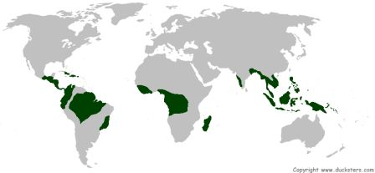
Biodiversity
The tropical rainforest has the most biodiversity of all the land biomes. Despite only covering around 6% of the Earth's surface, scientists estimate that around half of the planet's animal and plant species live in the world's rainforests.
Layers of the Rainforest
The rainforest can be divided up into three layers: the canopy, the understory, and the forest floor. Different animals and plants live in each different layer.
- The canopy - This is the top layer of trees. These trees are usually at least 100 feet tall. Their branches and leaves form an umbrella over the rest of the layers. Most of the plants and animals live on this layer. This includes monkeys, birds, insects, and reptiles of all sorts. Some animals can live their entire lives without leaving the canopy to touch the ground. This layer is the loudest layer with the animals making lots of noise.
- The understory - Beneath the canopy is the understory. This layer is made up of some shorter trees and shrubs, but mostly the trunks and branches of the canopy trees. This layer is home to some of the larger predators like snakes and leopards. It is also home to owls, bats, insects,frogs, iguanas, and various other animals.
- The forest floor - Because of the thickness of the canopy, very little sunlight makes it to the forest floor. This layer is home to lots of insects and spiders. There are also some animals that live on this layer including deer, pigs, and snakes. This layer is the quietest layer as animals sneak around in the dark making little noise.
Sometimes scientists refer to a fourth layer called the emergent layer. This is made up of tall trees that grow above the canopy.
What makes this biome so important?
The rainforests are important to the world for many reasons. One reason is that they act as the Earth's lungs by producing around 40% of the world's oxygen. Since all of us need oxygen to live, that reason ranks pretty high. The rainforests also provide a number of important drugs to help sick people and cure diseases. It is believed by many that there are even cures for cancer waiting for us to discover in the rainforest. The rainforest is also home to many species of animals and is a beautiful and irreplaceable part of nature.
The Disappearing Rainforests
Unfortunately, human development is killing off much of the world's rainforest. Around 40% of the world's rainforests have already been lost. Environmentalists are doing what they can to help countries preserve this vital biome.
Facts About Tropical Rainforests
- Surprisingly, the soil in a rainforest is shallow and has little nutrients.
- In the Amazon rainforest there are over 2,000 species of butterflies.
- They are home to interesting "flying" animals such as squirrels, snakes, and frogs.
- It is estimated that 25% of the ingredients in medicines today come from the rainforest.
- Rainforests impact the temperatures and weather patterns throughout the world.
- One fifth of the world's freshwater supply is in the Amazon rainforest.
- Every second, a section of rainforest the size of a football field is cut down.
- Only about 2% of the sunlight hits the forest floor.

Biomes  Temperate Forest | 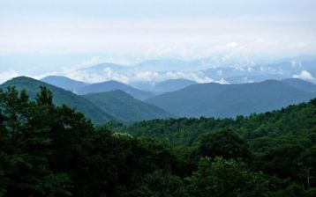
All forests have lots of trees, but there are different types of forests. They are often described as different biomes. One of the main differences is where they are located in relation to the equator and the poles. There are three main types of forest biomes: the rainforest, the temperate forest, and the Taiga. Rainforests are located in the tropics, near the equator. Taiga forests are located far north. Temperate rainforests are located in between.
What makes a forest a temperate forest?
- Temperature - Temperate means "not to extremes" or "in moderation". In this case temperate is referring to the temperature. It never gets really hot (like in the rainforest) or really cold (like in the Taiga) in the temperate forest. The temperature is generally between minus 20 degrees F and 90 degrees F.
- Four seasons - There are four distinct seasons: winter, spring, summer, and fall. Each season is about the same length of time. With only a three month winter, plants have a long growing season.
- Lots of rain - There is lots of rain throughout the year, usually between 30 and 60 inches of rain.
- Fertile soil - Rotted leaves and other decaying matter provide a rich, deep soil that is good for trees to grow strong roots.
Where are the temperate forests located?
They are located in several locations around the world, around halfway between the equator and the poles.
Types of Temperate Forests
There are actually many types of temperate forests. Here are the main ones:
- Coniferous - These forests are made up mostly of conifer trees such as cypress, cedar, redwood, fir, juniper, and pine trees. These trees grow needles instead of leaves and have cones instead of flowers.
- Broad-leafed - These forests are made up of broad-leafed trees such as oak, maple, elm, walnut, chestnut, and hickory trees. These trees have big leaves that change color in the fall.
- Mixed coniferous and broad-leafed - These forests have a mix of conifers and broad-leafed trees.
Major Temperate Forests of the World
There are major temperate forests located around the world including:
- Eastern North America
- Europe
- Eastern China
- Japan
- Southeast Australia
- New Zealand
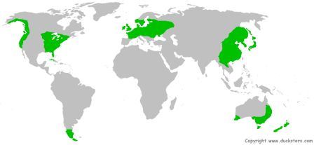
Plants of the Temperate Forests
The plants of the forests grow in different layers. The top layer is called the canopy and is made up of full grown trees. These trees form an umbrella throughout most of the year providing shade for the layers below. The middle layer is called the understory. The understory is made up of smaller trees, saplings, and shrubs. The lowest layer is the forest floor which is made up of wildflowers, herbs, ferns, mushrooms, and mosses.
The plants that grow here have some things in common.
- They lose their leaves - Many of the trees that grow here are deciduous trees, meaning they lose their leaves during the winter. There are a few evergreen trees as well that keep their leaves for the winter.
- Sap - many trees use sap to help them through the winter. It keeps their roots from freezing and is then used as energy in the spring to start growing again.
Animals of the Temperate Forests
There are a wide variety of animals that live here including black bears, mountain lions, deer, fox, squirrels, skunks, rabbits, porcupines, timber wolves, and a number of birds. Some animals are predators like mountain lions and hawks. Many animals survive off of nuts from the many trees like squirrels and turkeys.
Each species of animal has adapted to survive the winter.
- Remain active - Some animals stay active during the winter. There are rabbits, squirrels, fox, and deer which all stay active. Some are just good at finding food while others, like squirrels, store up and hide food during the fall that they can eat during the winter.
- Migrate - Some animals, like birds, migrate to a warmer place for the winter and then return home come springtime.
- Hibernate - Some animals hibernate or rest during the winter. They basically sleep for the winter and live off of fat stored in their body.
- Die and lay eggs - Many insects can't survive the winter, but they lay eggs that can. Their eggs will hatch come spring.
Facts About the Temperate Forest Biome
- Many animals have sharp claws to climb trees such as squirrels, opossums, and raccoons.
- Much of the forests in Western Europe are gone due to overdevelopment. Unfortunately, the ones in Eastern Europe are now dying from acid rain.
- A single oak tree can produce 90,000 acorns in one year.
- Trees use birds, acorns, and even the wind to spread their seed throughout the forest.
- Deciduous is a Latin word that means "to fall off".
- There were no ground living mammals in the New Zealand forests until people arrived, but there were lots of varieties of birds.
- Black bears will put on a 5 inch layer of fat before going to sleep for the winter.

Biomes  Taiga Forest | 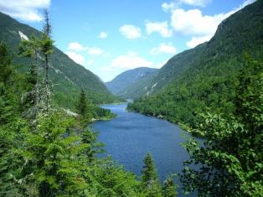
The Taiga is one of the three main forest biomes. The other two are the temperate forest and the tropical rainforest. The taiga is the driest and coldest of the three. The taiga is sometimes called the boreal forest or the coniferous forest. It is the largest of all the land biomes.
What makes a forest a taiga forest?
The taiga has several characteristics that distinguish it from the other forest biomes:
- Evergreen trees - This forest is covered with evergreen, or coniferous, trees. These are trees that don't drop their leaves, or needles, in the winter. They keep their leaves so they can soak up as much sunlight for as long as possible. The dark green color of their leaves also helps them to soak up more sun and gain more energy through photosynthesis.
- Cold weather - The taiga has the coldest weather of the forest biomes. Winters can get as cold as -60 degrees F. Winter can last for six months with the temperature averaging below freezing. Summers are warmer, but very short.
- Dry - The precipitation is only slightly more than the desert or the tundra. Average precipitation is between 12 and 30 inches per year. It falls as rain in the summer and snow in the winter.
- Thin layer of soil - Because the leaves don't fall from the trees, like in the temperate forest, the layer of good soil is thin. Also, the cold weather causes a slow rate of decay taking it longer for nutrients to get back into the soil.
- Short growing season - With a long winter and short summer, plants don't have a lot of time to grow in the taiga. The growing season only lasts for around three months. This compares to at least six months in the temperate forest and a year round growing season in the rainforest.
Where are the taiga forests located in the world?
These forests are located in the far north typically between the temperate forest biome and the tundra biome. On the globe this is between 50 degrees latitude north and the Arctic Circle. The largest taiga forest covers much of northern Russia and Siberia. Other major taiga forests include North America (Canada and Alaska) and Scandinavia (Finland, Norway, and Sweden).
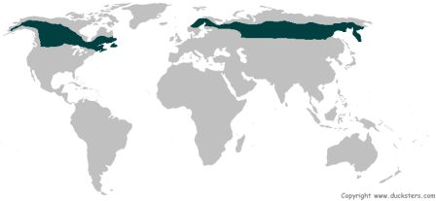
Plants of the Taiga
The dominant plant in the taiga is the coniferous evergreen tree. These trees include spruce, pine, cedar, and fir trees. They grow close together forming a canopy over the land, like an umbrella. This canopy soaks up the sun and only lets a little bit of sunlight through to the ground.
The conifers of the taiga produce their seeds in cones. They also have needles for leaves. Needles are good at holding in water and surviving the harsh cold winds each winter. The trees also grow in a cone shape. This helps the snow to slide off their branches.
Under the canopy of the trees, few other plants grow. In some moist areas plants such as ferns, sedges, mosses, and berries will grow.
Animals of the Taiga
The animals of the taiga must be able to survive the cold winters. Some animals, like birds, migrate to the south for the winter. Insects lay eggs that can survive the winter and then die. Other animals, like squirrels, store up food for the winter while others hibernate by going into a long, deep sleep.
Predators of this biome include the lynx, wolverines, Cooper's hawk, and wolves. Other animals include moose, the snowshoe hare, deer, elk, bears, chipmunks, bats, and woodpeckers.
Animals that live here have certain characteristics that help them to survive:
- They generally have thick fur or feathers to keep them warm.
- Many animals have sharp claws and are good at climbing trees.
- They have large feet to allow them to walk on the snow without sinking.
- Many of them change colors from white fur in the winter, to help them hide in the snow, to brown fur in the summer, to help them hide in the trees.
Facts About the Taiga Biome
- Taiga is a Russian word meaning forest.
- Many years ago the taiga was covered with icy glaciers.
- The word boreal means northern or "of the north wind".
- The occasional wildfire is good for the taiga as it opens up area for new growth. The trees have adapted to fires by growing tough bark. This will help some of them survive a mild fire.
- Many of the forest floor plants are perennials that come back each summer after laying dormant for the winter.
- These forests are endangered and shrinking due to logging.

Biomes - Marine
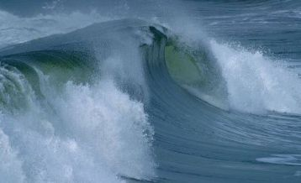
There are two major aquatic or water biomes, the marine biome and the freshwater biome. The marine biome is primarily made up of the saltwater oceans. It is the largest biome on planet Earth and covers around 70% of the Earth's surface. Go here to learn more about the world's different oceans.
Types of Marine Biomes
Although the marine biome is primarily made up of the oceans, it can be divided up into three types:
- Oceans - These are the five major oceans that cover the world including the Atlantic, Pacific, Indian, Arctic, and Southern Oceans.
- Coral reefs - Coral reefs are small in size when compared to the oceans, but around 25% of marine species live in the coral reefs making them an important biome. Go here to learn more about the coral reef biome.
- Estuaries - Estuaries are areas where rivers and streams flow into the ocean. This area where freshwater and saltwater meets, creates an ecosystem or biome all its own with interesting and diverse plant and animal life.
Ocean Light Zones
The ocean can be divided up into three layers or zones. These layers are called light zones because they are based on how much sunlight each area receives.
- Sunlit or euphotic zone - This is the top layer of the ocean and it gets the most sunlight. The depth varies, but averages around 600 feet deep. The sunlight provides energy to the ocean organisms through photosynthesis. It feeds plants as well as small little organisms called plankton. Plankton are very important in the ocean because they provide the food basis for much of the rest of ocean life. As a result, around 90% of ocean life lives in the sunlit zone.
- Twilight or disphotic zone - The twilight zone is the middle zone in the ocean. It runs from about 600 feet deep to around 3,000 feet deep depending on how murky the water is. There is too little sunlight for plants to live here. Animals that live here have adapted to living with little light. Some of these animals can produce their own light through a chemical reaction called bioluminescence.
- Midnight or aphotic zone - Below 3,000 or so is the midnight zone. There is no light here, it is completely dark. The water pressure is extremely high and it is very cold. Only a few animals have adapted to live in these extreme conditions. They live off of bacteria that get their energy from cracks in the Earth at the bottom of the ocean. Around 90% of the ocean is in this zone.
Animals of the Marine Biome
The marine biome has the most biodiversity of all the biomes. Many of the animals, such as fish, have gills that allow them to breathe the water. Other animals are mammals that need to come to surface to breathe, but spend much of their lives in the water. Another type of marine animal is the mollusk which has a soft body and no backbone.
Here are just a few of the animals that you will find in the marine biome:
- Fish - Sharks, swordfish, tuna, clown fish, grouper, stingray, flatfish, eels, rockfish, seahorse,sunfish mola, and gars.
- Marine mammals - Blue whales, seals, walruses, dolphins, manatees, and otters.
- Mollusks - Octopus, cuttlefish, clams, conch, squids, oysters, slugs, and snails.
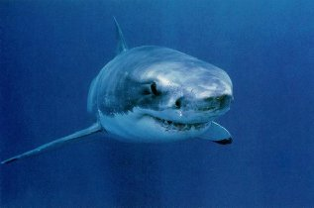
Great White Shark
Plants of the Marine Biome
There are thousands of species of plants that live in the ocean. They rely on photosynthesis from the sun for energy. Plants in the ocean are extremely important to all life on planet earth. Algae in the ocean absorbs carbon dioxide and provides much of the Earth's oxygen. Examples of algae include kelp and phytoplankton. Other ocean plants are seaweeds, sea grasses, and mangroves.
Facts About the Marine Biome
- Over 90% of the life on Earth lives in the ocean.
- The average depth of the ocean is 12,400 feet.
- Around 90% of all volcanic activity takes place in the world's oceans.
- The Mariana Trench is the deepest point in the ocean at 36,000 feet deep.
- The largest animal on Earth, the blue whale, lives in the ocean.
- Humans get most of their protein by eating fish from the ocean.
- The average temperature of the ocean is around 39 degrees F.

Biomes

Freshwater
There are two major types of aquatic biomes, the marine and the freshwater. The freshwater biome is defined as having a low salt content versus the marine biome which is saltwater like the ocean. Go here if you want to learn more about the marine biome.
Types of Freshwater Biomes
There are three main types of freshwater biomes: ponds and lakes, streams and rivers, and wetlands. We'll go into the details of each below.
Ponds and Lakes
Ponds and lakes are often called lentic ecosystems. This means that they have still or standing waters, not moving like rivers or streams. Go here to learn about the major lakes of the world.
Lakes are often divided up into four zones of biotic communities:
- Littoral zone - This is the area closest to the shore where aquatic plants grow.
- Limnetic zone - This is the open surface waters of the lake, away from the shore.
- Euphotic zone - This is the area below the surface of the water where there is still enough sunlight for photosynthesis.
- Benthic zone - This is the floor, or bottom, of the lake.
The temperature of lakes can change over time. In tropical areas the lakes will stay the same relative temperature with the water getting colder the deeper you go. In northern lakes, the change in temperature due to the seasons will move the water in the lake as shown below.
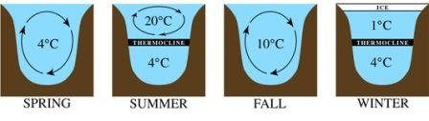
Lake animals - Animals include plankton, crayfish, snails, worms, frogs, turtles, insects, and fishes.
Lake plants - Plants include water lilies, duckweed, cattail, bulrush, stonewort, and bladderwort.
Streams and Rivers
Rivers and streams are often called lotic ecosystems. This means that they have flowing waters, unlike the still waters of ponds and lakes. This biome can vary in size dramatically from small trickling streams to mile wide rivers that travel for thousands of miles. Go here to learn about themajor rivers of the world.
Key factors influencing the ecology of streams and rivers include:
- Flow - the amount of water and the strength at which it flows will impact the types of plants and animals that can live in a river.
- Light - light has an impact because it provides energy to plants through photosynthesis. The amount of light due to seasons or other factors will impact the river's ecosystem.
- Temperature - The climate of the land the river is flowing through will have an impact on the local plant and animal life.
- Chemistry - this has to do with the type of geology that the river is flowing through. It impacts what type of soil, rocks, and nutrients are in the river.
River animals - Animals that live in or around the river include insects, snails, crabs, fishes such as salmon and catfish, salamanders, snakes, crocodiles, otters, and beavers.
River plants - Plants that grow around rivers vary greatly depending on the location of the river in the world. The plants typically live along the edge of the river where the water is moving slower. Plants include tapegrass, water stargrass, willow trees, and river birch.
Wetlands Biome
The wetlands biome is a combination of land and water. It can be thought of as land that is saturated with water. The land may be mostly underwater for part of the year or just flooded at certain times. One of the key characteristics of a wetland is that it supports aquatic plants.
Wetlands include bogs, swamps, and marshes. They are often located near large bodies of water like lakes and rivers and can be found throughout the world.
Wetlands can play an important role in nature. When located near rivers, wetlands can help to prevent flooding. They also help to purify and filter water. They are the home to many species of plants and animals.
Wetland animals - Wetlands have a huge diversity in animal life. Amphibians, birds, and reptiles all do well in the wetlands. The largest predators are alligators and crocodiles. Other animals include beavers, minks, raccoons, and deer.
Wetland plants - Wetland plants may grow entirely underwater or float on top of the water. Other plants grow mostly out of the water, like large trees. Plants include milkweed, water lilies, duckweed, cattail, cypress trees, and mangroves.
Facts about the Freshwater Biome
- Scientists that study freshwater bodies of water like ponds, lakes, and rivers are called limnologists.
- The amount of rainfall varies widely depending on where a wetland is located. It could be as little as seven inches per year to over a hundred inches per year.
- Marshes are wetlands without trees.
- Swamps are wetlands that grow trees and have seasonal flooding.
- Tidal swamps are sometimes called mangrove swamps because the mangroves can grow in the mix of freshwater and saltwater.
- The largest lake in the world is the Caspian Sea.
- The longest river in the world is the Nile River.
- The largest wetland in the world is the Pantanal in South America.

Biomes  Coral Reef | 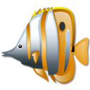
The coral reef is one of the major marine biomes. Although it is a relatively small biome, around 25% of the known marine species live in coral reefs.
What is a coral reef?
At first glance, you may think that coral reefs are made up of rocks, but they are actually live organisms. These organisms are tiny little animals called polyps. Polyps live on the outside of the reef. As polyps die, they become hard and new polyps grow on top of them causing the reef to grow.
Does the coral reef eat?
Since polyps need to eat to stay alive, you can think of the coral reef as eating, too. They eat small animals called plankton as well as algae. The algae get their food from the sun by usingphotosynthesis. This is why coral reefs form close to the surface of the water and in clear water where the sun can feed the algae.
Where are coral reefs located?
Coral reefs need warm, shallow water to form. They form close to the equator near coastlines and around islands throughout the world.
A significant portion of the world's coral reefs are located in Southeast Asia and near Australia. The largest coral reef is the Great Barrier Reef located off of Queensland, Australia. The Great Barrier Reef stretches for 2,600 miles.
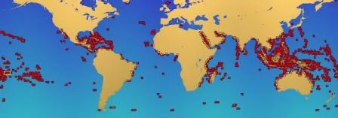
Coral reefs of the world in red
Types of Coral Reefs
There are three main types of coral reefs:
- Fringe reef - Fringe reefs grow close to the shore line. It can be attached to the shore or there may be a narrow strip of water called a lagoon or channel between the land and the coral reef.
- Barrier reef - Barrier reefs grow further from the shore line, sometimes several miles from the shore.
- Atoll - An atoll is a ring of coral surrounding a lagoon of water. It starts out as a fringe reef around a volcanic island. As the coral grows up, the island sinks into the ocean and just the ring of coral is left. Some atolls are so big that people live on them. An example of this is the Maldives.
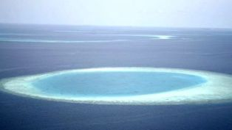
Coral Reef Atoll
Zones of the Coral Reef
After a period of time, coral reefs develop zones. Each zone is inhabited by different kinds of corals, fish, and ocean life.
- Shore or inner reef zone - This area is between the crest and the shoreline. Depending on the shape of the reef, this area can be full of life including fishes, sea cucumbers, starfish, and anemones.
- Crest reef zone - This is highest point of the reef and where the waves break over the reef.
- Fore or outer reef zone - As the reef wall falls off, the waters get calmer. Around 30 feet deep, you will generally find the most populated part of the reef along with lots of different types of coral species.
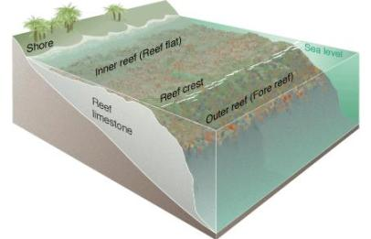
The coral reef can be divided into zones
Coral Reef Animals
All sorts of animals live around a coral reef. This includes many different types of corals such as star coral, brain coral, column coral, cactus coral, and finger coral.
Some of the most strange and interesting creatures in the world live here. Many animals attach themselves to the reef covering nearly every square inch. They include sponges, starfish, anemones, cucumbers, snails, and clams. Also, there are lots of fish swimming around such as cuttlefish, sharks, lionfish, pufferfish, clownfish, and eels. There are 1500 species of fish and 400 species of coral that live on the Great Barrier Reef alone.
Coral Reef Plants
The majority of the plants living on the coral reef are various species of sea grass, seaweed, and algae.
Why are the coral reefs important?
Besides being beautiful, a tourist attraction, and an important part of planet Earth, coral reefs have a positive impact on many people throughout the world. This includes food from fishing, protection of coastlines from erosion, and even medical discoveries such as medicines for cancer.
Are they in danger?
Yes, the coral reefs are slowly being destroyed. Since they grow at such a slow rate, they are disintegrating faster than they can be repaired. Much of the damage is caused by humans, primarily from pollution and overfishing. Even tourists can damage the reefs by standing on them, touching them, or bumping into them with their boats.
Facts About the Coral Reef
- Coral reefs grow very slowly. Large reefs grow at the rate of 1 to 2 cm per year. It's estimated that some of the largest reefs took as long as 30 million years to form.
- Some animals in the coral reef have symbiotic relationships. This means they help each other to survive. The clown fish and the anemone are one example of this.
- Different types of coral grow into different shapes. Some look like mushrooms, some trees, fans, honeycombs, flowers, and even brains.
- The Great Barrier Reef is so big it can be seen from outer space.
- Some coral reefs have turned white because they lose their algae when the water gets too salty or warm.

