Name:___________________________________________Date:______________Period:____________
Station One
- Plants that use photosynthesis to make their own food are called ___________________________ or ________________________________.
- What ingredients are required for photosynthesis to occur?

3. How do plants collect the required ingredients?

4. What is made during photosynthesis that the chemical energy is stored in?

5. What is the pigment found in plants called?

6. In what plant organelle does photosynthesis take place?

Station 2:
Digestive System Organ | Physical Change | Chemical Change
Mouth
Stomach
Small Intestine

Station 3
1. What is a plant growth response to a stimulus? ____________________________________________
2. What are the three most critical plant tropisms to? _________________________________________ _____________________________________________________________________________________
3. A plants growth response to light is called ________________________________________________.
4. A plants growth response to gravity is called ______________________________________________.
5. A plants growth response to water is called _______________________________________________.
6. Growth response can be ______________________________ or _____________________________.
7. Positive tropism is _________________________________ the stimulus.
8. Give an example of a positive tropism.

9. Negative tropism is _________________________________ from the stimulus.
10. Give an example of a negative tropism.

11. How do plants control their responses?

Station 4
1. A tomato plant uses the sun for photosynthesis to make food for itself.

2. Eating spaghetti before you use your muscles to run a marathon.

3. Your muscles are constantly moving during the marathon, which heats your body and makes you sweat.

4. A firefly uses chemicals in its body to produce a glowing body.

5. Chemicals cause electrons to move down your nerve cells, which cause your legs to jump to move you away from a poisonous snake.

Answer these questions:
6. Where do organisms get chemical energy from?
7. What type of energy is produced while an organism digests their food?
8. What needs to happen for energy to be transformed into mechanical energy?

Station 5
Stimuli

Internal External

Station 6
1. What makes up all living and non-living things?

2. What is a molecule made of?

3. TRUE/FALSE: All molecules are the same shape.

4. Why is digestion important?

5. How are carbohydrates broken down into glucose?

6. How are proteins broken down into amino acids?

7. How are fats digested?

Station 7
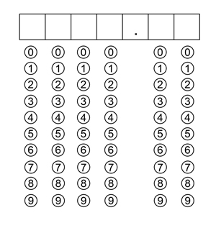
1. It takes 20 N of force to move a box 10 meters. How much work is done on the box in Joules? Bubble in your answer below.

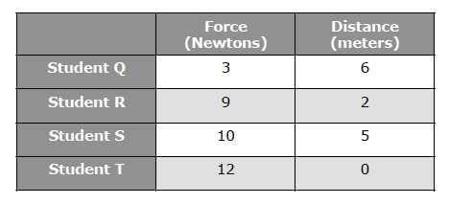
2. The table shows the amount of force four students used to push a box different distances. Which two students performed the same amount of work?
- Student Q, Student R
- Student S, Student T
- Student Q, Student T
- Student R, Student S

3. When an object is lifted directly from the ground rather than moved with an inclined plane, which of the following will be increased?
- The mass of the object
- The work done on the object
- The force needed to move the object
- The amount of friction acting on the object
4. A student lifts an object to a certain height with no tools. Another student lifts the same object to the same height using a ramp. Which of the following remains the same for both students?
- The friction acting against the object
- The amount of work done on the object
- The horizontal distance the object travels
- The force used to move the object
5. All of the following describe situations in which work is done by an organism EXCEPT for which situation?
- A bird carries a worm to its nest.
- A squirrel hides nuts in a tree.
- Ants bring crumbs into their home.
- Leaves decompose on the forest floor.

Station 8
Signs of Physical Changes | Signs of Chemical Changes

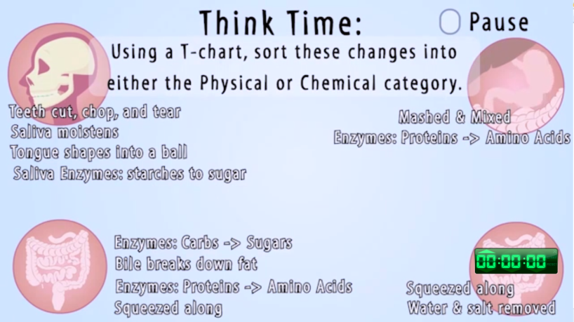
Station 9

Physical Changes Chemical Changes

