2015-2016 8th Grade Science Semester Exam REVIEW
Atomic Structure and Chemistry
- How do you determine the mass of an atom?

Protons + Neutrons or Atomic # + Neutrons

- How do you determine the atomic number of an atom?

Count the number of protons or Atomic Mass – Neutrons

- Describe the location, mass and charge for:

Proton: nucleus, 1 amu, positive (+)
Neutron: nucleus, 1 amu, neutral (0)
Electron: electron cloud outside of nucleus, 0 amu, negative (-)

- Which particles in an atom determine the chemical reactivity of the element?

Valence electrons, specifically the number of them

- Locate Metals, Non-Metals, Metalloids on the Periodic Table of the Elements.
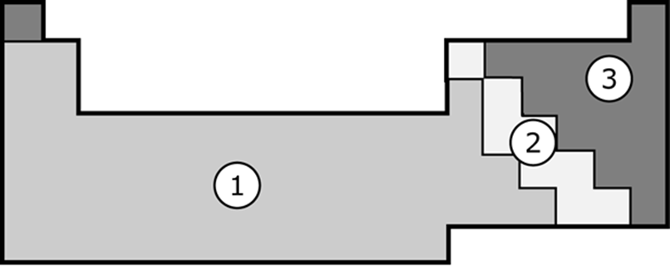

1 – metals
2 – metalloids (located along the stair-step or zig-zag line)
3 – non-metals

- Which direction do you move in the periodic table for increasing mass?

Left to right along the period

- How do you know if an element reacts like another element?

It has the same number of valence electrons.

- What is the difference between an element and a compound?

An element is one atom (or two atoms that are the same like H₂) and a compound is a combination of different elements.
- List evidence that a chemical reaction has occurred

a. Temperature change
b. Color change
c. Odor change
d. Gas forms
e. Precipitate (solid) forms

- What information can you get from a chemical formula? (Hint: Tell everything you can about this formula: C₂O₂H₄)

The elements in the formula and the number of atoms of each element.
Ex. 2 carbon atoms, 2 oxygen atoms, 4 hydrogen atoms

- Determine if the following equation is balanced (follows the Law of Conservation of Mass) using a RAP chart.
light
C₃H₈ + 5 O₂ 3 CO₂ + 4 H₂O

R A P
3 C 3
8 H 8
10 O 10 Balanced

Physics

- How do you compute the density of an object?

Mass divided by volume (D=m/v)

- What is the difference between Speed, Velocity and Acceleration? (Hint: list definitions to help you!)

Speed is the distance an object travels over a certain amount of time.
Velocity is the speed plus the direction in which the object travels.
Acceleration is a change in the velocity.

- What is inertia?

An objects resistance to a change in its motion. If it is moving, it will resist stopping. If it is stopped, it will resist moving.

- Illustrate and describe an example of when an object will move according to the forces acting on it. (Hint: Balanced and unbalanced forces, direction of movement.)

Objects will only move because of unbalanced forces. Here, 10 is greater than 5. The object will move towards the right because that is the direction of the greater force.

If the forces are balanced, there is no change in motion.

- Given the force and acceleration of an object, how do you compute the object’s mass?

Mass = Force / acceleration

- What is the equation for determining force?

Force = mass x acceleration

- What is the force on an object with a mass of 0.23kg, and an acceleration of 3.5m/s²?

F=ma
F=(0.23 kg)(3.5 m/s²)
F=0.805 N

- If two objects with different masses travel down a hill at the same speed, which object will require more force to stop?

The object with the most mass will require the most force. Force and mass are directly proportional. When one goes up, so does the other.

Components of the Universe

- Why can people on Earth NOT see the shape of the Milky Way?

We are inside of the galaxy. That is like trying to see the whole school while sitting in a classroom. We are not able to travel far enough to be able to look back or take a picture of the entire galaxy.

- What information is available on a Hertzsprung-Russell diagram?

Surface temperature of a star
Brightness or luminosity of a star
Color of a star
Group of the star (main sequence, giant, supergiant, dwarf)
How one star compares to another star in any of the above

- Write the following types of electromagnetic radiation in order from longest wavelengths to shortest.
X-rays Microwaves Gamma Rays Infrared Ultraviolet Visible Light Radio Waves

Radio, Micro, Infrared, Visible, UV, X-ray, Gamma

- Write the following colors of the visible light spectrum in order from longest wavelengths to shortest.
Indigo Red Green Orange Blue Yellow Violet (Purple)

Red, Orange, Yellow, Green, Blue, Indigo, Violet
ROY G BIV

- Astronomers use the visible spectrum to complete a spectral analysis of stars. What does the spectral analysis tell them?

What type of elements are present in the star by lining up the spectral analysis of elements with the ones from the star. If the lines from the element are present in the star, the star has that element in it.

