Category 2: Force, Motion & Energy

A. Energy Transformations

Law of Conservation of Energy – energy cannot be created or destroyed, it only changes its form
R Energy
E Energy
C Energy
T Energy
M Energy
P Energy
K Energy
A Energy
N Energy

Alternative Energy = Wind, Solar, Geothermal, Hydroelectric, Biomass/Biofuels, etc.

Energy Conversions

Photosynthesis in a plant

__________ energy from sun converted to __________ energy (glucose) in leaf

Fuel conversion in a moving car

__________ energy to __________ energy

Stored energy in a battery

__________ chemical energy to __________ energy

Energy Resources

__________ = plants, animals, soil

__________ = Fossil fuels (use the word CONserve for C-coal, O-oil, N-natural gas)

__________ energy

- __________ is the source of all energy on Earth (it also drives the water cycle).

- Energy is not recycled, but it __________ through systems (like food chains).

B. Motion, Forces & Energy

Identify examples of kinetic and potential energy - know maximum locations

Example: pendulum, roller coaster, objects falling over a waterfall, etc.

Example: roller coaster physics: __________ of the track (the __________) is the point possessing the highest “potential energy” for the rollercoaster, and the highest “kinetic energy” is the point at the __________ of the track (the __________).

In summary, potential energy is being built up as roller coaster moves __________. It gains stored energy due to a change in its position. The force of gravity converts the potential energy to kinetic energy as the coaster rolls __________.

Newton’s Laws

State and apply Newton’s Laws of Motion. Review inclined plane, pulley, etc.

Law of Inertia (object at rest will remain at rest; an object in motion will remain in motion, at a constant velocity unless acted upon by an __________ __________.

__________ why a small car gets better gas mileage than a big car.

For every __________, there is an equal and opposite __________. Forces come in pairs.

Define balanced and unbalanced forces.

Example: During a game of tug of war, if the rope does not move, then forces are __________, with the net force equal to __________.

Forces are __________ if the net force does NOT add up to __________.

Describe how forces act upon the motion of an object. Which way will the object move?

Demonstrate than an object will remain at rest or move at a constant speed unless acted upon by an unbalanced force.

Time-distance graph

interprets motion, with time being measured on the __________ axis and distance on __________ axis.

When time continues, but distance does not change, the object is NOT in motion, or rather, it stopped moving.

Displayed on a line graph, __________ would be a plateau or flat line.

Time-position graphs (walk to school, take a rest – flat line, walk back home)

Interpret graphs and analyze patterns.

A line graph best shows a change in __________ __________.

A bar graph best shows a __________ of two or more dependent variables.

A pie graph or pie chart is a comparison of several parts to the whole (__________ or __________).

Joule (__________) - used to measure work (__________).

1__________ = amount of work done moving 1N a distance of 1 meter

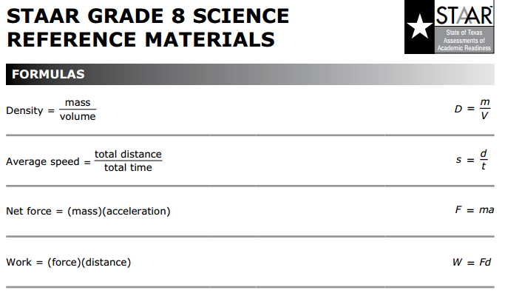

Practice the work formula: W = F x d (Work = Force x distance)

If the force applied to an object has not moved the object, __________ work has been done!
The distance moved (if there is one) is usually on the __________ on the test.

Practice calculating force formula: F = m X a (Force = __________ x __________)
(can be rewritten using weight)

Newton’s 2nd Law:

Weight = m x g (Weight = mass x gravity constant = 9.8 m/sec/sec)

Weight is a measure of the force of gravity.

Understand the difference between __________ (a constant) and __________, using Newtons (__________).

Example: The force of gravity on the moon is 1/6 of the Earth’s gravity.

__________is important in determining an object’s weight, but NOT its mass.

Force is measured in units called __________ (N).

One __________is the force on a 1 __________mass that will accelerate that mass to 1________.

Demonstrate that acceleration occurs when an object __________, __________, or changes its __________ of motion. It only occurs when an unbalanced net force acts on an object.

The __________ must be large enough to overcome the object’s motion.

FORCES to living organisms - Plant & Animal Responses

Plant Roots - __________ pulls roots downward - Gravitropism

Heart – exerts a __________ force to pump blood around body

Seedlings – As seeds germinate or sprout, seedlings __________ up through soil.

Plants - Phototropism – plants bending toward light (the shaded side of stem grows faster)

