Create Your Own Dichotomous Key

In this project, you will be creating a dichotomous key. Dichotomous keys are tools used by scientists to identify unknown organisms. To create your key, follow the steps outlined below. All completed projects will be worth 50 points and will be graded according to the attached rubric. Good Luck, Have Fun, and Be Creative!
- Choose a group of non-scientific items that interest you. Example: Candy, Shoes, Aliens, etc.
- Select 10 different species from this group. Locate and print out or create pictures of each one. These will be included in your project.
- Decide upon a way to divide the items into two groups. Think of identifying characteristics such as shape, size, position, color, texture, etc. One characteristic must be defined and used to decide which items are placed in which group. For example: a group of big cats could be divided into those with long tails and those with short tails. The groups created must be opposites of each other.
- Record what factor was used to make the division and note which members of the original group belonged to each resulting group.
- After two groups (A and B) have been created, divide the first group (A) into two more groups based again on one criterion (C and D). For example, if group A were the short tailed cats, group C might be short tailed cats with a plain colored coat. Group D would then be short tailed cats with a patterned coat.
- Do the same with Group B.
- Continue to divide the groups until each item is by itself. Keep careful records of the groups that were created and the dividing criteria.
- Looking at your records and the divisions you made, create a dichotomous key that would lead someone else to make the same distinctions you did. Begin your key by recalling the first factor you used to divide into two groups. Again using the big cat example: The first group was created depending on tail length. So, the first question in the key should be: Does the cat have a short tail? If so, go to step 2. The second question should be the other choice: Does the cat have a long tail? If so, go to step ??? (You may need to wait until you have worked through several steps of the key to assign the second destination.
- You can use the attached paper as a framework to fill in your key or you can type your own.
- When your key is complete, ask someone else to use it to classify and identify the items. Does your key lead others to the same identifications you made? If not, you may need to make some changes.

Important Requirements!!!
- Include a page with the 10 illustrations you selected. They should be identified ONLY by the letters A-J. DO NOT INCLUDE THE NAMES ON THIS PAGE!!!

- Provide an answer key as the last page of your project.

Helpful Hints:
- While you are constructing your key, you must be as specific as possible so that the user does not become confused. If the two choices are not precise, a user can easily choose the wrong one, and may get the wrong classification or have to start over.

- Have several people use the key to see if their answers match with yours. If they do not, analyze the key with them and compare your choices to see where they got confused. You may need to re-word your choices.

- All keys should have one fewer steps than items. So your key should have 9 steps with two choices for each one.

Grading Rubric: Your project will be graded according to the following rubric:
______20 pts. Ten colorful, clear, accurate, and easy to understand illustrations were provided.
______ 10 pts. A completed answer key was provided.
______20 pts. All steps of Dichotomous Key were complete.
______20 pts. The Dichotomous Key followed the proper structure (identifying characteristics were used to create steps of paired opposites).

______20 pts. The Dichotomous Key was accurately worded. I successfully used it to identify all 10 items.

______ 10 pts. The Dichotomous Key included proper spelling, punctuation and grammar. All included documents were neat, legible, and easy to identify.

______/100 Total points

Illustration Page:

Key Template: Use the following template to create your dichotomous key OR you may construct a graphical dichotomous key.
Title: Key to Identifying __________________________ Go To:
Step 1 | 1a.
 | 1b.
Step 2 | 2a.
 | 2b.
Step 3 | 3a.
 | 3b.
Step 4 | 4a.
 | 4b.
Step 5 | 5a.
 | 5b.
Step 6 | 6a.
 | 6b.
Step 7 | 7a.
 | 7b.
Step 8 | 8a.
 | 8b.
Step 9 | 9a.
 | 9b.

Answer Key: Fill in the correct answers to your ordered illustrations.

- ___________________________________________

- ___________________________________________

- ___________________________________________

- ___________________________________________

- ___________________________________________

- ___________________________________________

- ___________________________________________

- ___________________________________________

- ___________________________________________

- ____________________________________________

Solving a classmates dichotomous key:
Who’s dichotomous key are you solving?________________________________
Below write your answers for your classmate’s species as you identify them.
- ___________________________________________

- ___________________________________________

- ___________________________________________

- ___________________________________________

- ___________________________________________

- ___________________________________________

- ___________________________________________

- ___________________________________________

- ___________________________________________

- ____________________________________________

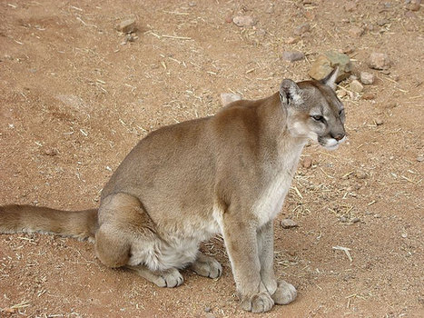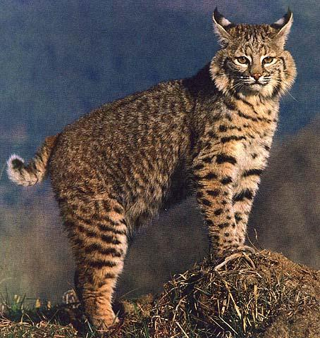
A B

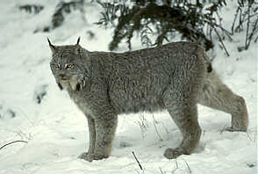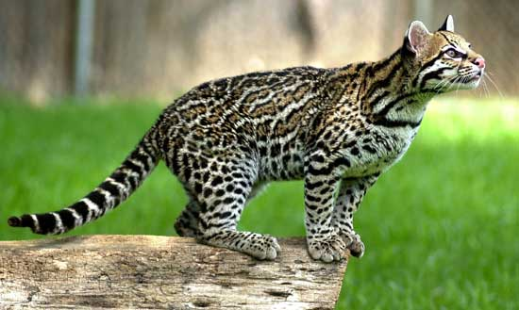
C D

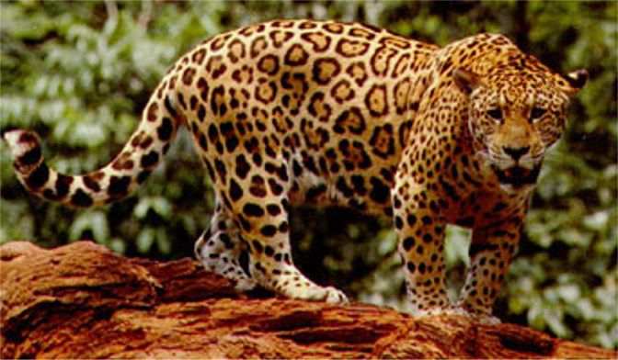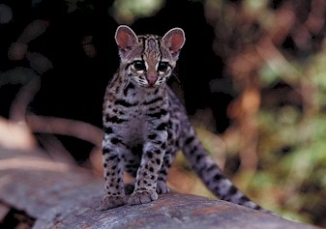
E F

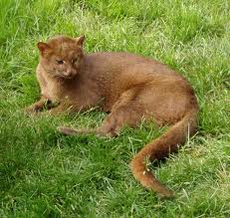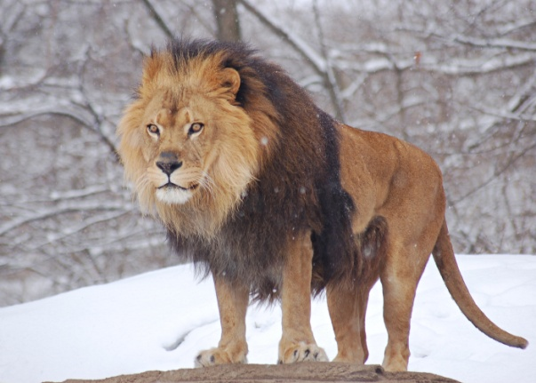
G H

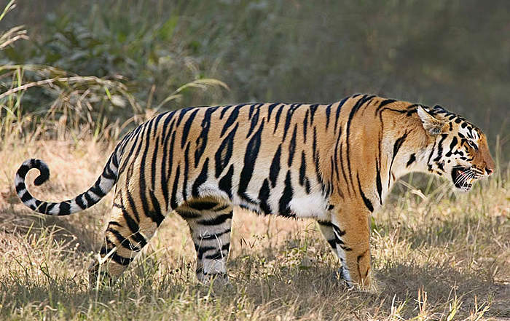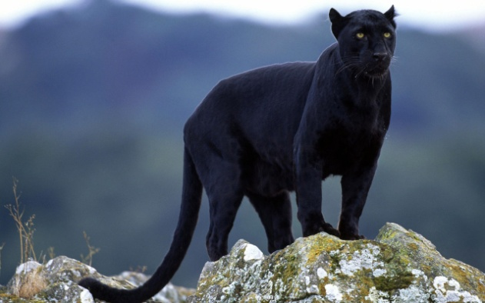
I J

Key to Wild Cats Name: ________________________
Period: ____________

1a. The cat has a short tail……………………………………………………….go to Step2
1b. The cat has a long tail………………………………………………………….go to Step 3

2a. The cat is speckled with long ear black-tipped ear tufts
and long,beard-like cheek ruff……………………………………….it is a lynx, Felis lynx
2b. The cat has indistinct spots, short ear tufts, white spots on its ears,
and a broad cheek ruff………………………………………………………it is a bobcat, Felis rufus

3a. The cat has a plainly colored body………………………………..go to Step 4
3b. The cat has a patterned body………………………………………….go to Step 7

4a. The cat has a distinct mane around
its neck (males only)…………………………………………………………..it is a lion, Panthera leo
4b. The cat has no mane around its neck…………………………..go to Step 5

5a. The cat is mostly tan to brown in color………………………go to Step 6
5b. The cat is black in color…………………………………….it is a black leopard, Panther pardus

6a. The cat is tan above with white to buff below………….it is a mtn. lion, Felis concolor
6b. The cat is brown all over the body……………………….it is a jaguarondi, Felis yagouarundi

7a. The cat has an orange colored body with noticeable
black stripes……………………………………………………………….it is a Bengal tiger, Panthera tigris
7b. The cat has a pattern on its body other than stripes……………go to Step 8

8a. The cat is clearly larger than a house cat…………………..go to Step 9
8b. The cat is about the same size as a house cat…………..it is a margay, Felis wiedii

9a. The cat has black-bordered brown spots, tending to
form lines on the body………………………………………………………it is an ocelot, Felis pardalis
9b. The cat is large, spotted with black rosettes or rings in
horizontal rows…………………………………………………………………..it is a jaguar, Panathera onca

Answer Key

- Mountain lion, Felis concolor

- Bobcat, Felis rufus

- Lynx, Felis lynx

- Ocelot, Felis pardalis

- Jaguar, Panathera onca

- Margay, Felis wiedii

- Jaguarondi, Felis yagouarundi

- Lion, Panthera leo

- Bengal tiger, Panthera tigris

- Black leopard, Panther pardus

