Cornell Notes | Topic/Objective: Photosynthesis |  | Name:
 |  |  | Class/Period:
 |  |  | Date: 9/10/14 – 9/11/14
Essential Question: Identify that radiant energy is from the sun. How is radiant energy transformed into chemical
energy during photosynthesis? What is the equation of photosynthesis?
Questions: |  | Notes:
Summary:
Questions: |  | 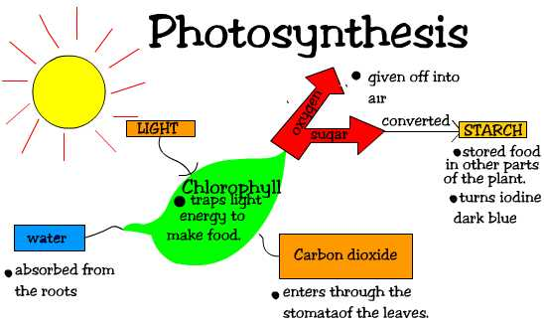  Notes:
Summary:

