- Leeches are organisms that live in ponds. They feed on the blood of fish and other vertebrates and produce enzymes, which cause the animal on which it feeds to continue bleeding even after the leech is done feeding. This relationship would be classified as …
Freshwater parasite/host

- Describe a predator/prey relationship in a freshwater environment.
Dragonflies capture and eat mosquito larvae in a river.

- Describe a terrestrial parasite/host relationship.
Nematodes are tiny worms that feed on trees and cause disease in them.

- One of the major effects the oceans have on our terrestrial environment here on Earth is:
Heat transfer within ocean water affects climates.
- An illustration of a water lily is provided.
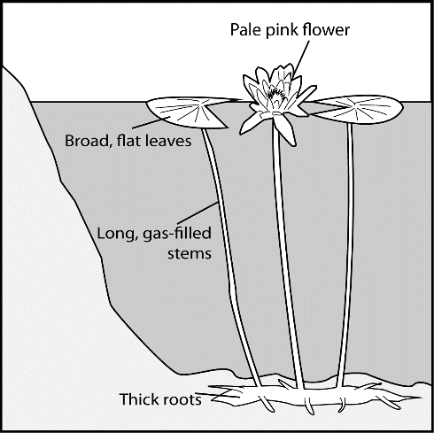
If annual rainfall increased and caused ponds in this habitat to become deeper, how, after many generations, might the traits of these water lilies change?
Longer stems

- The Venus Fly Trap (Dionaea muscipula) is a plant, and like all other green plants, gets its energy from the Sun through photosynthesis. This plant, however, catches flies and breaks down their bodies using the chemicals to meet its needs. Which environmental condition led to this adaptation?
Soil with few nutrients
- Chemicals used on crops to control insects affect ocean ecosystems when they –
Are washed into oceans, adding harmful substances.

- Refer to the tables provided.
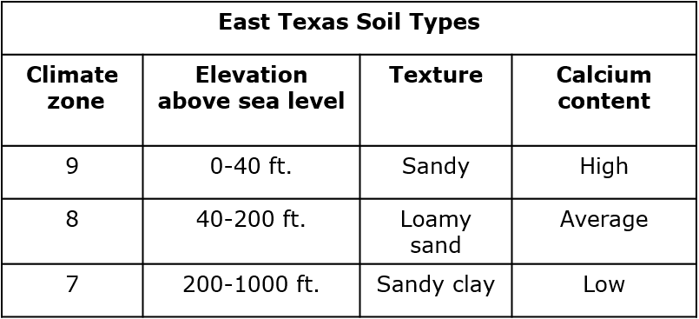
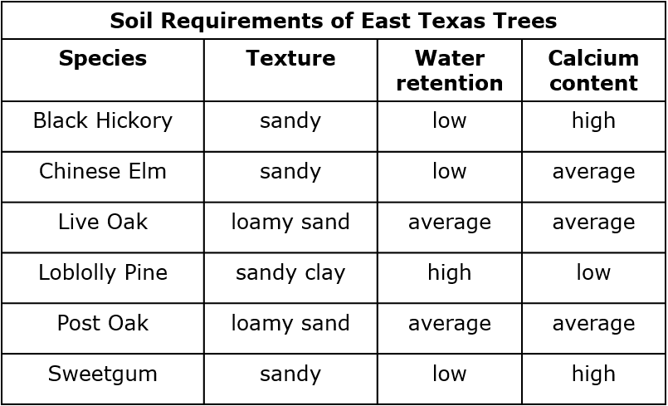
Which plants depend on and may compete for sandy soil in zone 9?
Black Hickory and Sweetgum
- Which human activities will have a negative impact on the balance of organisms within an ocean ecosystem?
Commercial fishing to provide food for humans
- The aggressive South American cane toad was introduced to Australia by humans. Information about the cane toad is provided in the table.
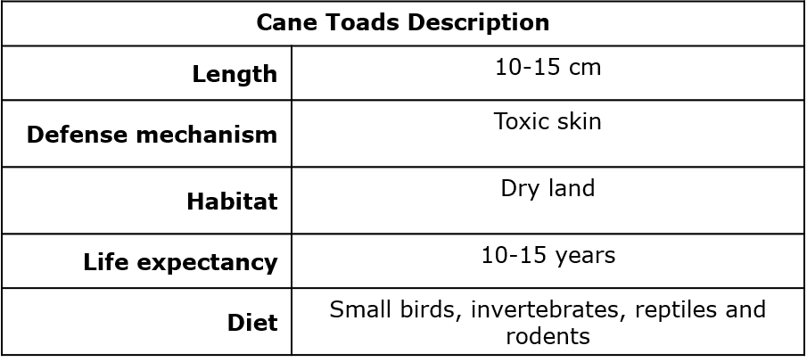
Based on the table, native organisms will be negatively affected by competition with cane toads if they –
Eat reptiles.

- Even before modern observations provided evidence that supports the Theory of Plate Tectonics, people developed theories that the continents were once joined together. Using only maps, they observed that:
The shapes of continents appeared to allow them to fit together.

- The border between two tectonic plates lies below the state of California. The interaction of these two plates results in
Frequent earthquakes

- How did examining rocks that form on either side of the Mid-Atlantic Ridge provide evidence that supports the theory of Plate Tectonics?
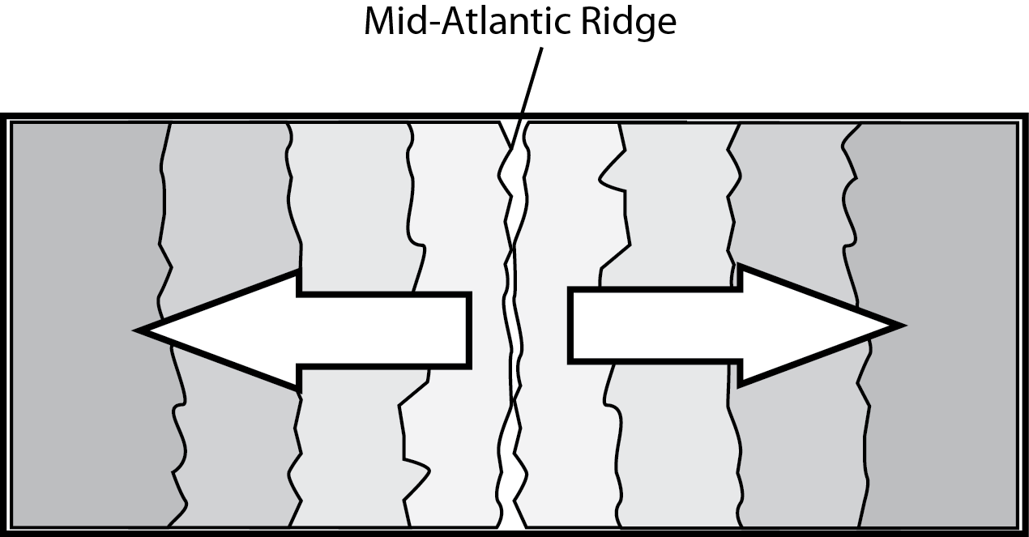
Hint: As we look at rocks farther and farther from the ridge, the rocks…
Are consistently older.

- The most recently formed crust on Earth would be found where?
Two plates are moving apart from each other.

- Which land feature is likely to form where two tectonic plates push toward each other?
Mountain range

- Stars are made mostly of which two elements?
Hydrogen and helium

- A river is running through the region represented by the topographic map shown here.
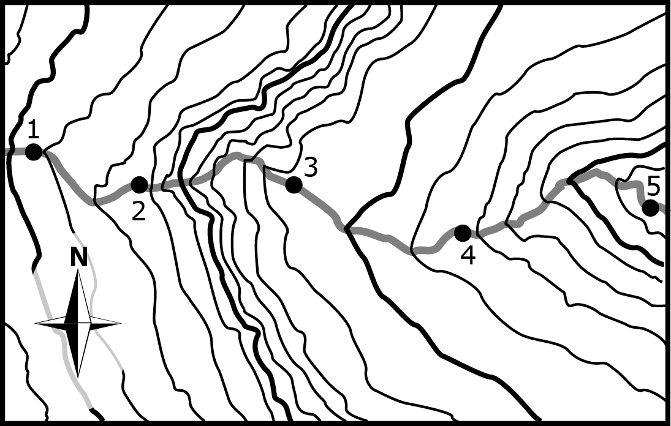
In which portion of the river will the water be flowing fastest?
Between Point 2 and Point 3

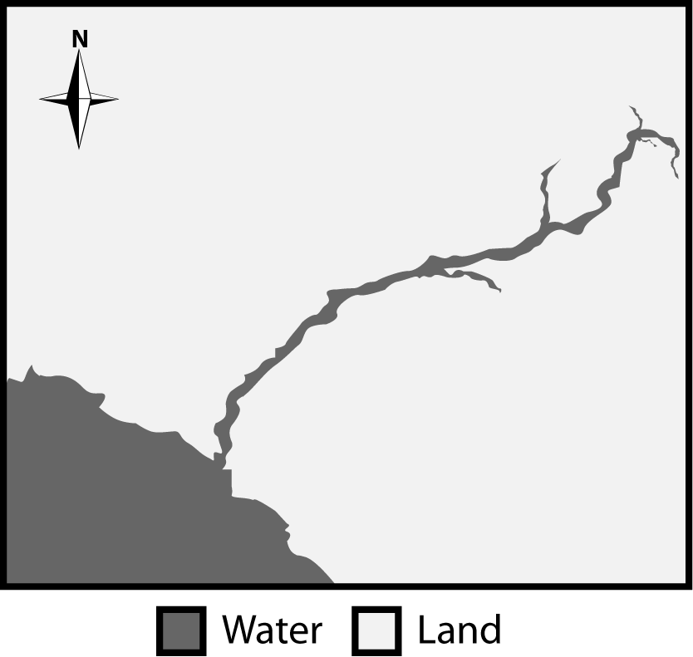
- A picture of a satellite image with a river flowing over land is provided.
Which direction is the river is flowing?
Southwest.

- The satellite photograph below shows a large meteorite crater that is 1200 m in diameter and 170 m deep. This crater is located in a flat, arid part of northeastern Arizona.
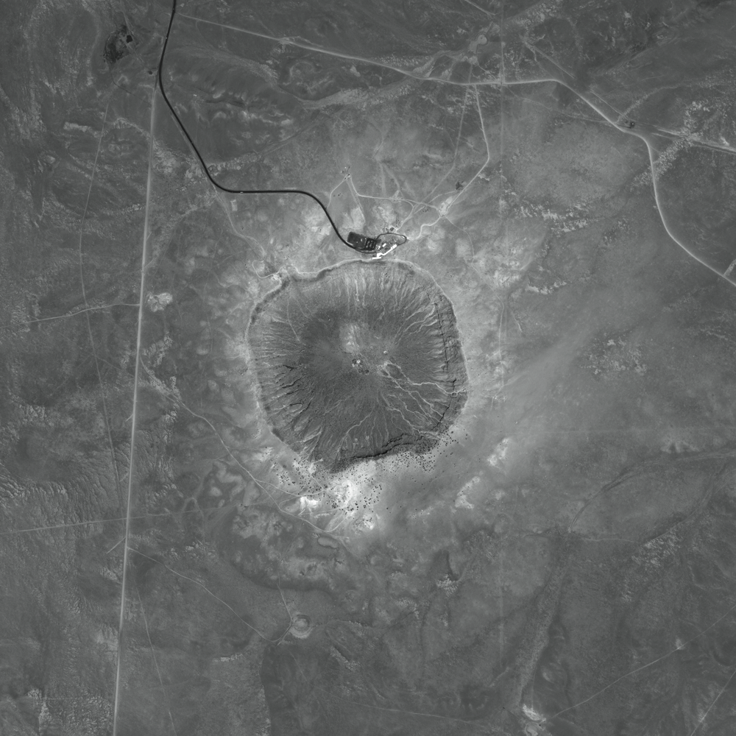
How will this crater most likely change over time?
It will become less deep as the rim erodes.
- Tides are the result of forces exerted on Earth’s oceans mostly by which celestial body?
The Moon
- Describe the relative size of the Sun compared to other stars.
Medium-sized compared to all stars
- A system of stars, gas, dust, and dark matter bound together by gravity is called –
A galaxy.
- A map of sea surface temperatures is provided.
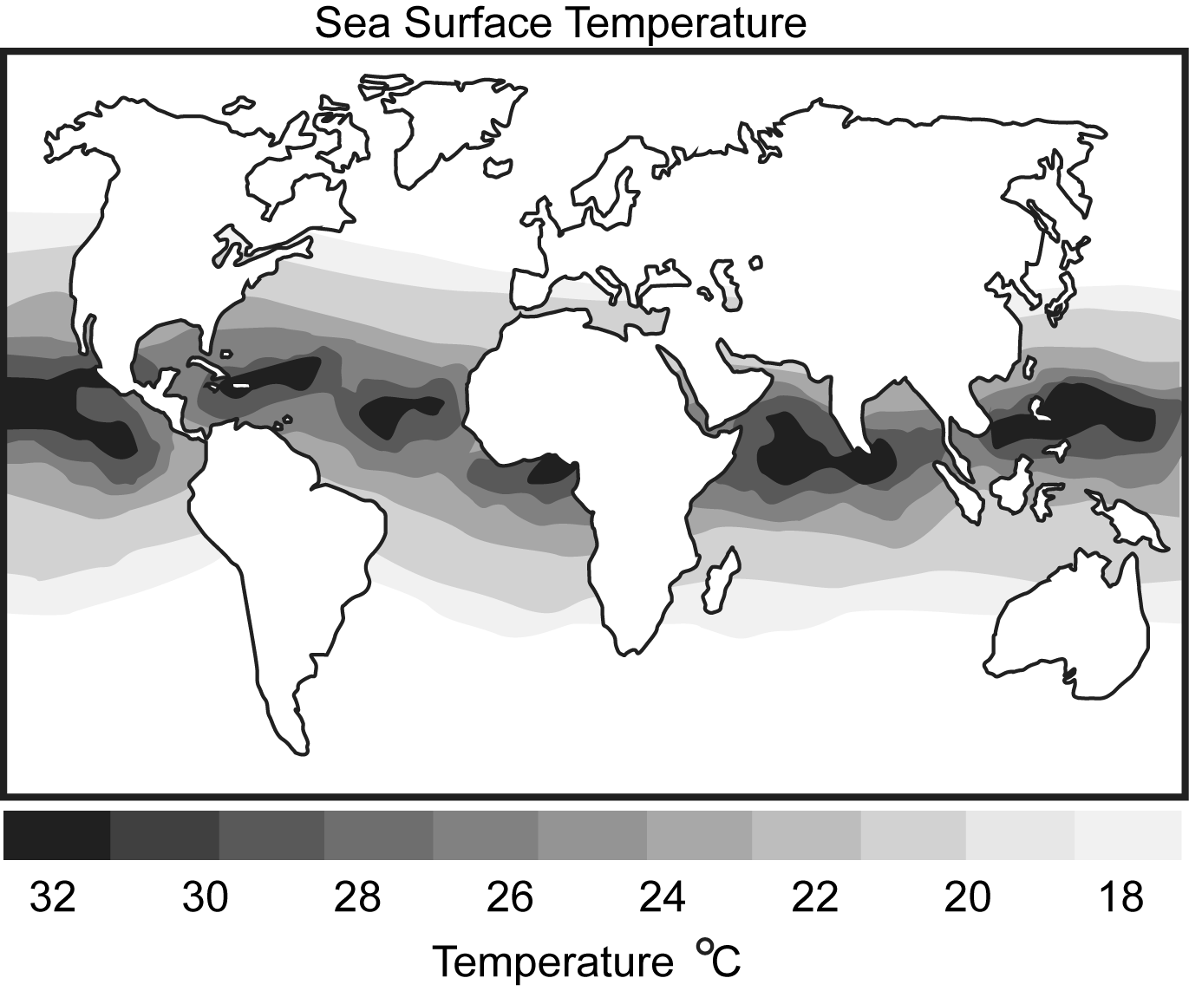
The patterns in thermal differences that generate ocean currents are explained by the fact that _____.
The Equator receives more of the Sun’s radiation than other parts of Earth.

- Which lunar phase will occur approximately 7 days after a first quarter moon?
Full moon

- The sun is classified as which type of star on the H-R Diagram?
Main Sequence

- What causes Earth to have day and night?
Earth’s rotation on its axis

- The Jet Stream is a global pattern of atmospheric movement that influences patterns in local weather.
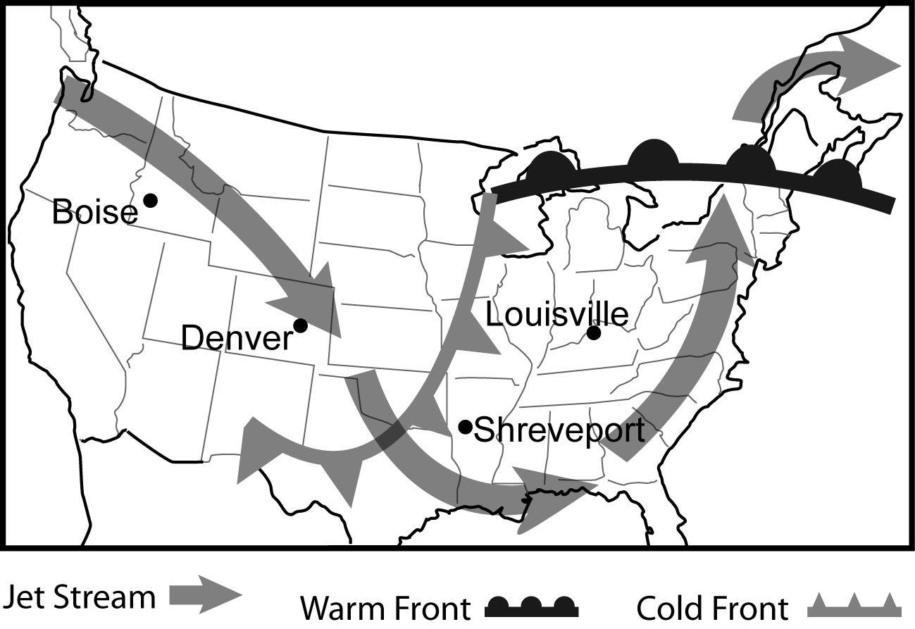
Based on the information provided in the weather map, which city shown most recently saw a rise in temperature?
Louisville

- Using the diagram of the Electromagnetic Spectrum, which portion of wave patterns would best illustrate the visible light wave pattern that we see?
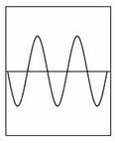

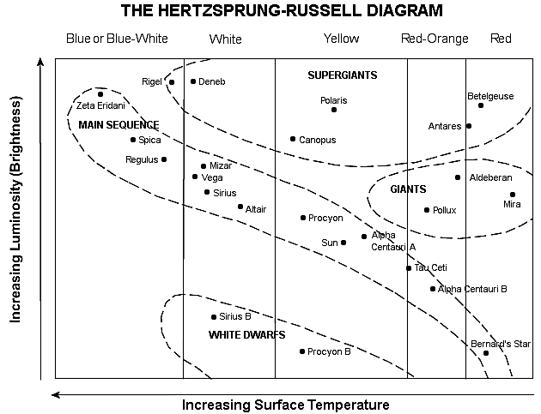
- In the Herztsprung-Russell diagram above, we see a group of stars in the Main Sequence. What is the relationship between a star’s temperature and luminosity (brightness)?
As the temperature increases, the luminosity increases.
- Students use the materials pictured here to create a model of the lunar cycle.
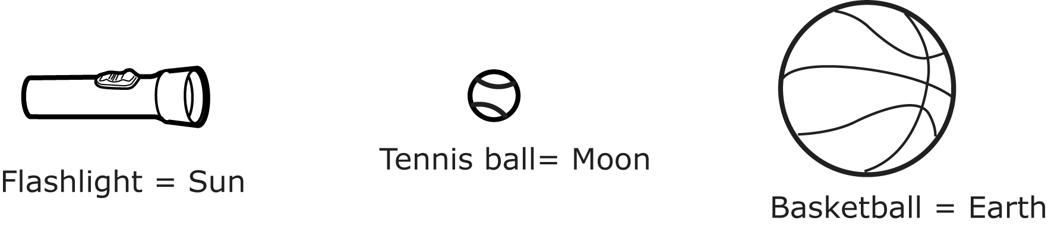
Describe the action the students must perform to demonstrate what causes the changing appearance of the Moon from Earth.
Moving the tennis ball around the basketball.

- A student is using a globe to model the seasons. If the northern hemisphere is tilted towards the Sun, what season is occurring in Texas?
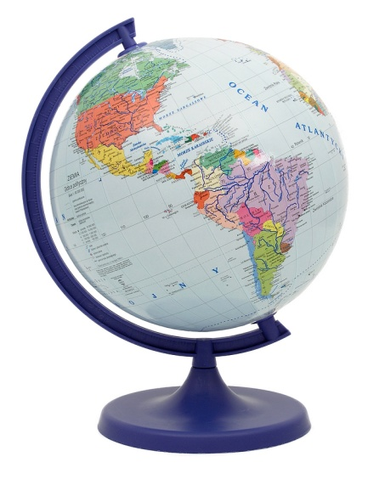
Summer

- Proxima Centauri is the closest star to Earth after the Sun and is located 4.3 light years away from Earth. How long does it take light from Proxima Centauri to reach Earth?
4.3 years

- Why does the Moon have a greater effect on ocean tides than the Sun?
The Moon has a greater gravitational pull on Earth’s oceans because it is much closer.

- Describe the position of the Sun relative to other objects in space?
On the edge of the Milky Way Galaxy

- One piece of evidence that supports the Theory of Plate Tectonics is the discovery of what in both South America and Africa?
Fossil remains of the same land-dwelling animal were found on each continent.
- A hiker planning a trip up a mountainside might want to select the face of the mountain which provides the easiest hike. When looking at a topographic map, what would indicate the part of the mountain that would provide the easiest path for the hiker to take?
Contour lines spaced far apart

- If the greatest erosion on a mountain will occur where the slope is the steepest, one could locate this portion of a mountain on a topographic map by looking for the area where the topographic lines –
Are closest together.

- Identify the major source of energy that creates hurricanes.
Sun’s radiation

- Fleas consume the blood of mammals for their food source. Often the bite of a flea can cause illness. This relationship would be classified as _____.
Terrestrial parasite/host

- A topographic map is provided.
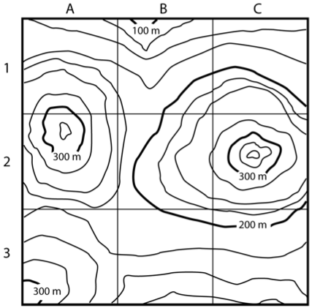
The highest peak represented by the topographic map can be found in which quadrant?
C2

- Describe a parasite/host relationship in a marine environment.
Copepods feed on the eyes of sharks, blinding them.

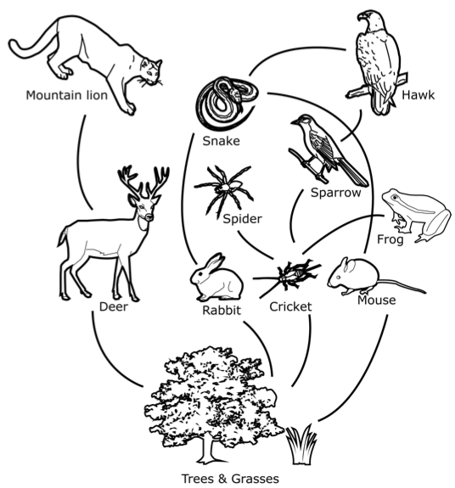
- The terrestrial food web is provided.
Which pair of organisms represents a producer/consumer relationship?
Mouse & grass

- A nucleotide consists of a nitrogenous base, along with –
A sugar and phosphate.

- List the nitrogenous base pairings.
Cytosine/guanine
Adenine/Thymine
- A diagram of the DNA double helix is provided.

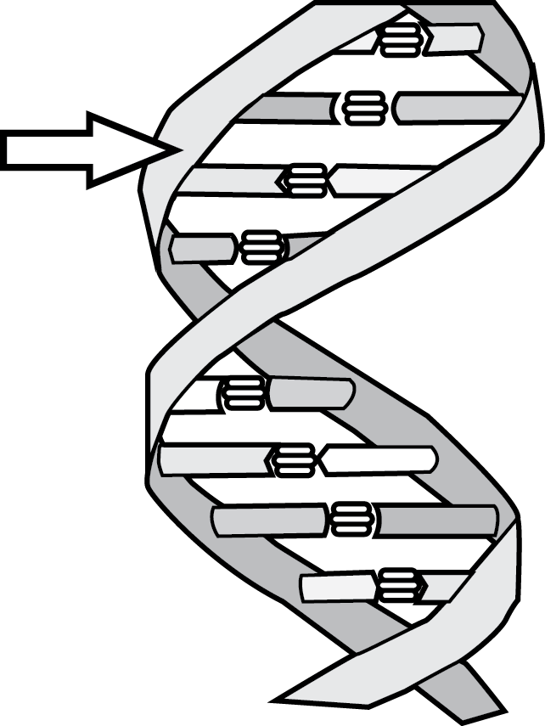
Which component of DNA is indicated by the arrow?
Sugar-phosphate backbone

- All living things have _____ which supports the idea that the genetic code is common to all living things.
Genes using the same nitrogenous bases.

- A similarity between proteins, carbohydrates, lipids, and nucleic acids is that they all –
Contain the element carbon.

- Which unknown substance represents a carbohydrate in the data table shown?
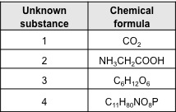
3

- Which biomolecule is the major energy source for cells?
Carbohydrates

- Which biomolecule is composed of three basic elements: carbon; hydrogen; and oxygen, and can be found in the form of unsaturated or saturated fats?
Lipids

