Name:__________________________________________________Date:______________________________Block:_________________________

T.W.O.S. Review
1) Label the seasons for the Northern Hemisphere in the diagram below.

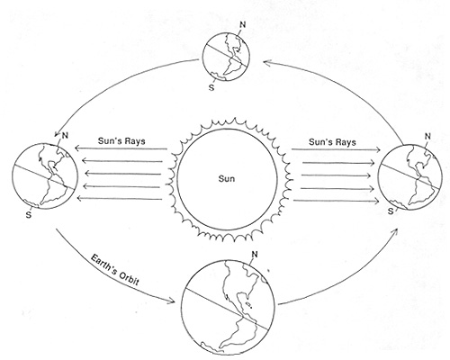
2) Describe 2 reasons the Earth has seasons

3) Determine what happens to the weather during a cold front.

4) How would you identify a warm front on a weather map? (draw and indicate color)

5) Describe convection in the ocean.

6) What explanation do you have for the formation of clouds at the Inter Tropical Convergence Zone (ITCZ)? Explain the process IN DETAIL.

7) Describe the flow of currents in the northern hemisphere.
8) What determines whether a current carries warm or cold water?

9) What can be inferred about the positions of the Sun, Earth and Moon when an unusually large tidal range occurs?

10) Name the 4 different types of air masses and describe the characteristics of each.

11) Predict the weather in Mansfield, TX if there is an “L” located over the area on a weather map.

12) Determine the original source of energy for convection in air masses?

13) Compare the gravitational pull of the Sun and Moon on the Earth and evaluate which one has the greater effect on Earth’s tides.

14) How would you identify a cold front on a weather map? (draw and indicate color)

15) Determine which front you would expect to have less precipitation, but be longer lived as the front slowly passes.
16) Which weather highway would you associate with controlling our weather?

17) What term describes the amount of moisture in the air?
18) Describe the convection currents in the atmosphere.

19) How would you identify a stationary front on a weather map? (draw and indicate color)

20) The northern hemisphere is cooler in the winter and warmer in the summer. Justify this statement.

