Name:___________________________________________________ Period:_______________________
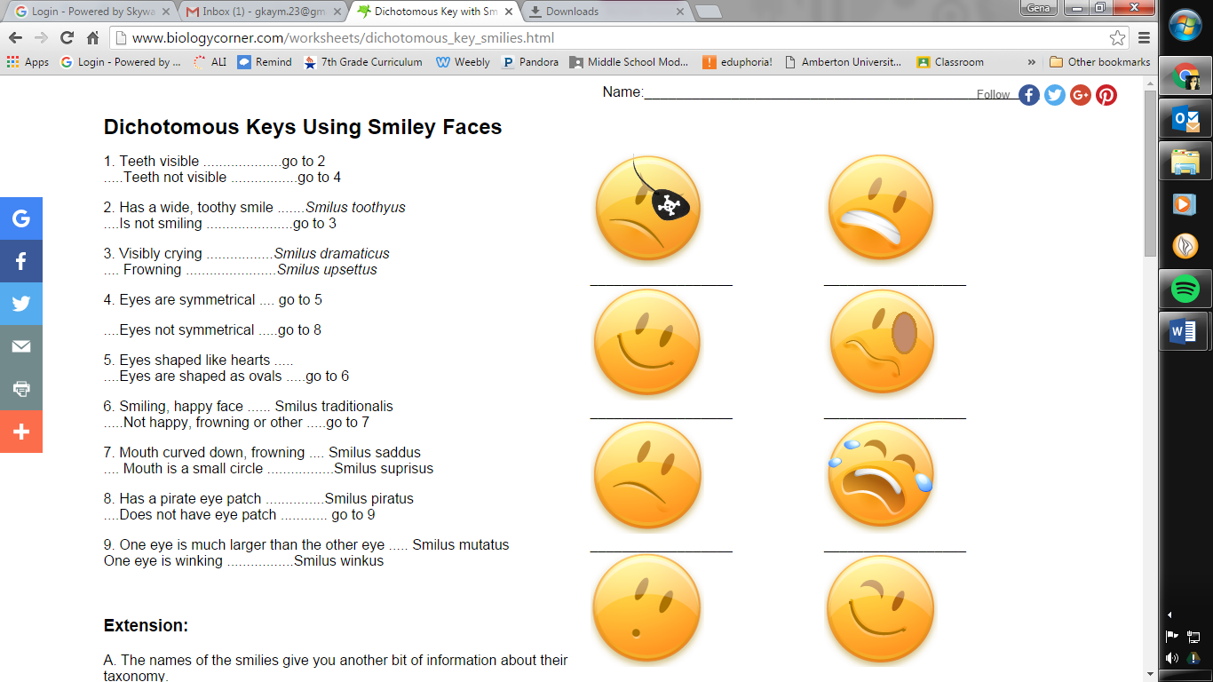
Warm Up Worksheet – Feb. 15-19

Monday

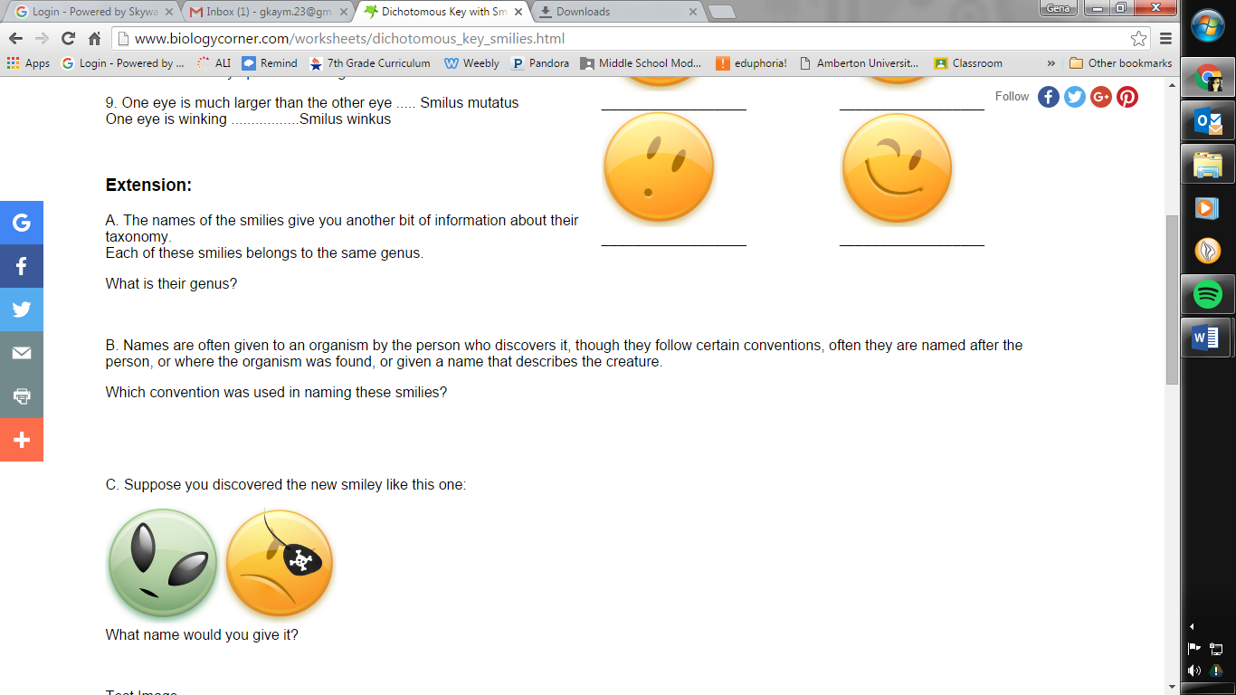
Tuesday

Scientific Name of shark:
_________________________________________
Wednesday

Thursday
Identify each snake by using the dichotomous key.
Snake 1: _____________________________________
Snake 2: _____________________________________
Friday
Snake3: _____________________________________
Snake 4: _____________________________________
Snake 5: _____________________________________

