**What to put on your foldable:**

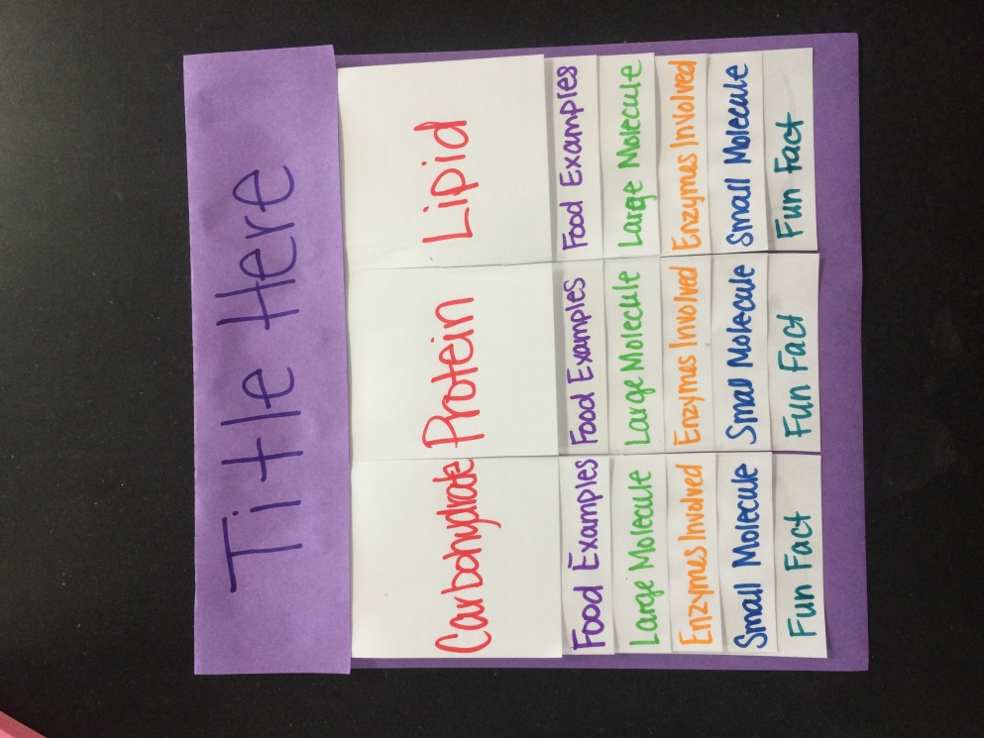

Fun Fact: Research one fun fact about the molecule

Small Molecules: What does the large molecules break down into during digestion?

Food Example: Give 3 examples of food that are high in the molecule.

Large Molecule: You are to cut and paste the picture of the structure of each molecule. There is a copy at bottom of paper.

Enzymes Involved: Tell me what is used to break down the molecule.

Come up with a title that has to do with this topic. 

Large Molecules:

